CHILDHOOD INTERVENTIONS, LLC
USER GUIDE
COS Scoring Tool
Child Outcome Summary documentation with AI-assisted narrative generation and IFSP-ready PDF export — for Florida Early Steps.
🧮 COS Ratings 🤖 AI Narratives 📄 IFSP-Ready PDF 📈 Progress Tracking
🛡 HIPAA Compliance & Data Privacy
Tools that handle Protected Health Information (PHI) operate under a Business Associate Agreement (BAA) with Childhood Interventions, LLC. This guide includes a dedicated HIPAA & Privacy section explaining exactly where your data is stored and what leaves your browser. Never store PHI in personal cloud storage (iCloud, personal Google Drive, personal Dropbox) without a BAA in place.

In this guide
- Overview
- Accessing the Tool
- The 7-Point Rating Scale
- Completing a COS
- Exit COS
- AI-Generated Narratives
- Tracking Progress Over Time
- Saving & Exporting
- HIPAA & Privacy

🧮 Overview
The Child Outcome Summary (COS) Scoring Tool streamlines the federal-required COS process for Part C providers. It guides you through rating all three outcome areas, captures the supporting rationale, uses AI to help draft narrative language, and generates a clean PDF ready for the IFSP team.
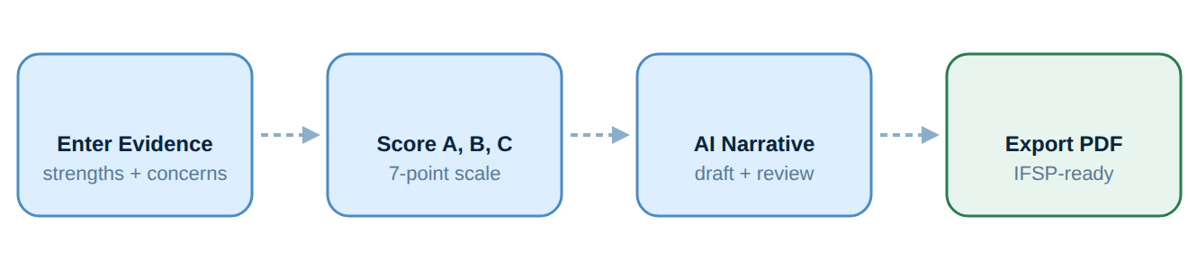
Workflow overview.
- 🧮 Guided 7-Point Scoring — Decision trees and anchor descriptions guide you to the correct rating for each outcome area — reduces rating variability across the team.
- 🤖 AI Narrative Drafts — After scoring, AI generates a supporting narrative for each outcome area based on the evidence you entered. Review and edit before finalizing.
- 📈 Progress Over Time — Track COS ratings across multiple evaluation points to document child progress in the federal reporting format.
- 📄 IFSP-Ready Export — Export a formatted PDF that includes all three outcome ratings, narrative summaries, and the progress indicator for use in IFSP meetings.
🔑 Accessing the Tool
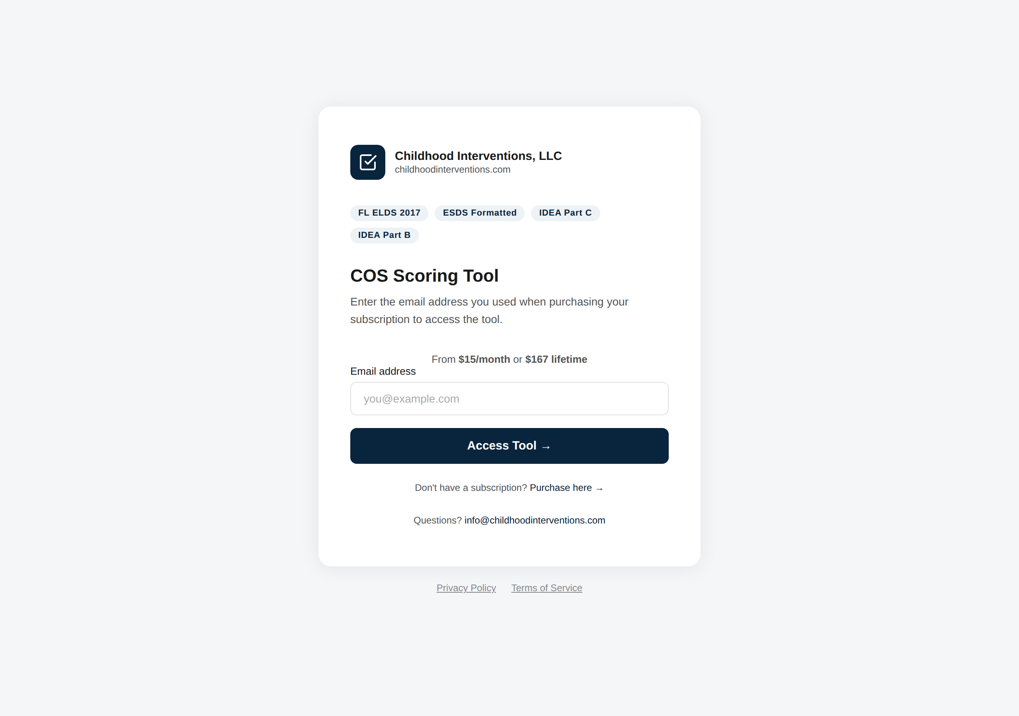
The COS Scoring Tool sign-in screen. Enter the email address tied to your subscription and click Access Tool.
The COS Scoring Tool is accessed through the Provider Hub or directly at cos.childhoodinterventions.com. Your Hub login email is used for authentication — no separate sign-in needed when coming from the Hub.
💡 Coming from the Provider Hub: click COS Scoring Tool on your dashboard and you'll be taken in directly with your email pre-validated. Your child roster from EI Session Notes is also accessible in the COS tool.

🎚️ The 7-Point Rating Scale
COS ratings use a 7-point scale defined by federal Early Intervention guidelines. The scale below defines each rating point. How you arrive at a rating depends on whether you are completing an entry or an exit COS — see "How ratings are set" below.
Rating | What it means
1 | Child does not yet show skills in this area
2 | Child shows a few early skills but they are not yet immediate foundational skills
3 | Child shows some immediate foundational skills but not all — skills not age-appropriate
4 | Child shows some age-appropriate skills but not consistently or across settings
5 | Child's skills are age-appropriate and consistent across settings and situations
6 | Child shows age-appropriate skills and some skills beyond age expectations
7 | Child's skills are well beyond age expectations across all settings and situations

How ratings are set — entry vs. exit. The two COS types are scored from different sources, so the workflow is different for each.
Entry COS. Ratings come from the child's eligibility evaluation. On the Child Info step, use the Eval Entry card to bring the evaluation into the tool, then the crosswalk to set the ratings:
- Paste the eval narrative. Open the eligibility evaluation that was written (the Assessment page), select all and copy it, then choose Eval Entry → Paste from Eval Doc, paste it in, and click Import. The tool reads the narrative and pulls each outcome's functioning.
- …or complete the eval in the tool. Choose Eval Entry → Enter During Eval to jot messy notes for each outcome (what the child does well and has a hard time with), plus collateral/family information and clinical opinion, then click Polish Notes. This keeps your eligibility eval and COS together in one place.
- Set the ratings with the crosswalk. Open the Eligibility evaluation crosswalk and enter the DAYC-2 (or BDI-3) subtest scores. The tool suggests and applies an entry rating for each outcome.
- No skills checklist for entry. The Score Outcomes Yes/No checklist is an exit-COS tool — you don't use it for an entry COS.
💡 Enter the age-equivalent score — not just the standard score. The crosswalk sets the COS rating by comparing each subtest's age-equivalent (age-expected) score, in months, to the child's age. That age-equivalent value is what drives the rating, so it must be entered — a standard score on its own will not produce a rating.

📝 Bring in the narrative — not just the scores. The subtest scores set the numeric rating, but the tool writes each outcome's current-functioning narrative from the evaluation text you paste or enter. A specific, example-rich evaluation narrative produces accurate, defensible descriptions; scores alone give you a number without the story behind it. Bring in the full evaluation narrative, not just the subtest scores.

⚠️ Keep PHI out of Eval Entry. Whether you paste an eval doc or use Enter During Eval, the text is sent to the AI to polish. Enter only skills and behaviors — no child name, date of birth, diagnosis, or address. (Name and DOB are automatically removed if detected, but it is safest to leave them out.)

Exit COS. Switch the COS type to Exit COS. Ratings reflect the child's current functioning, drawn from your documentation:
- Upload your documentation (preferred). In the Upload supporting documents panel, drop in session notes, progress summaries, periodic reviews, or FL ELDS checklists (PDF, Word, or text) and click Generate Exit Narratives. The AI reads them to draft each outcome's current-functioning and Progress-Since-Entry narrative.
- …or score by hand. On the Score Outcomes step, mark each skill Yes/No within its developmental band — use All Y / All N to move quickly, and tap the ⓘ icon on any skill for FL ELDS examples.
- Confirm the rating. Either way, the tool produces a suggested 1–7 rating for each outcome that you confirm or adjust on Review & Export.
⚠️ Your exit COS is only as good as your notes. The AI drafts exit ratings and narratives from the documents you upload, so specific, functional, example-rich session notes produce accurate, defensible ratings — vague notes produce vague results. This is exactly why strong documentation throughout the year matters: good session notes are what make a fast, accurate exit COS possible. You are the clinician — always review and adjust the AI's rating and narratives before exporting.

📊 Progress indicators are automatic — when entry ratings are on file. When you set the COS type to Exit COS, the tool loads the child's entry ratings and calculates each outcome's progress indicator (a, b, c) automatically once you enter the exit ratings — no manual calculation needed. This only works if the entry information is available: load it from the Entry COS save file (Option A) or enter it under Entry COS Data first.

✅ Completing a COS
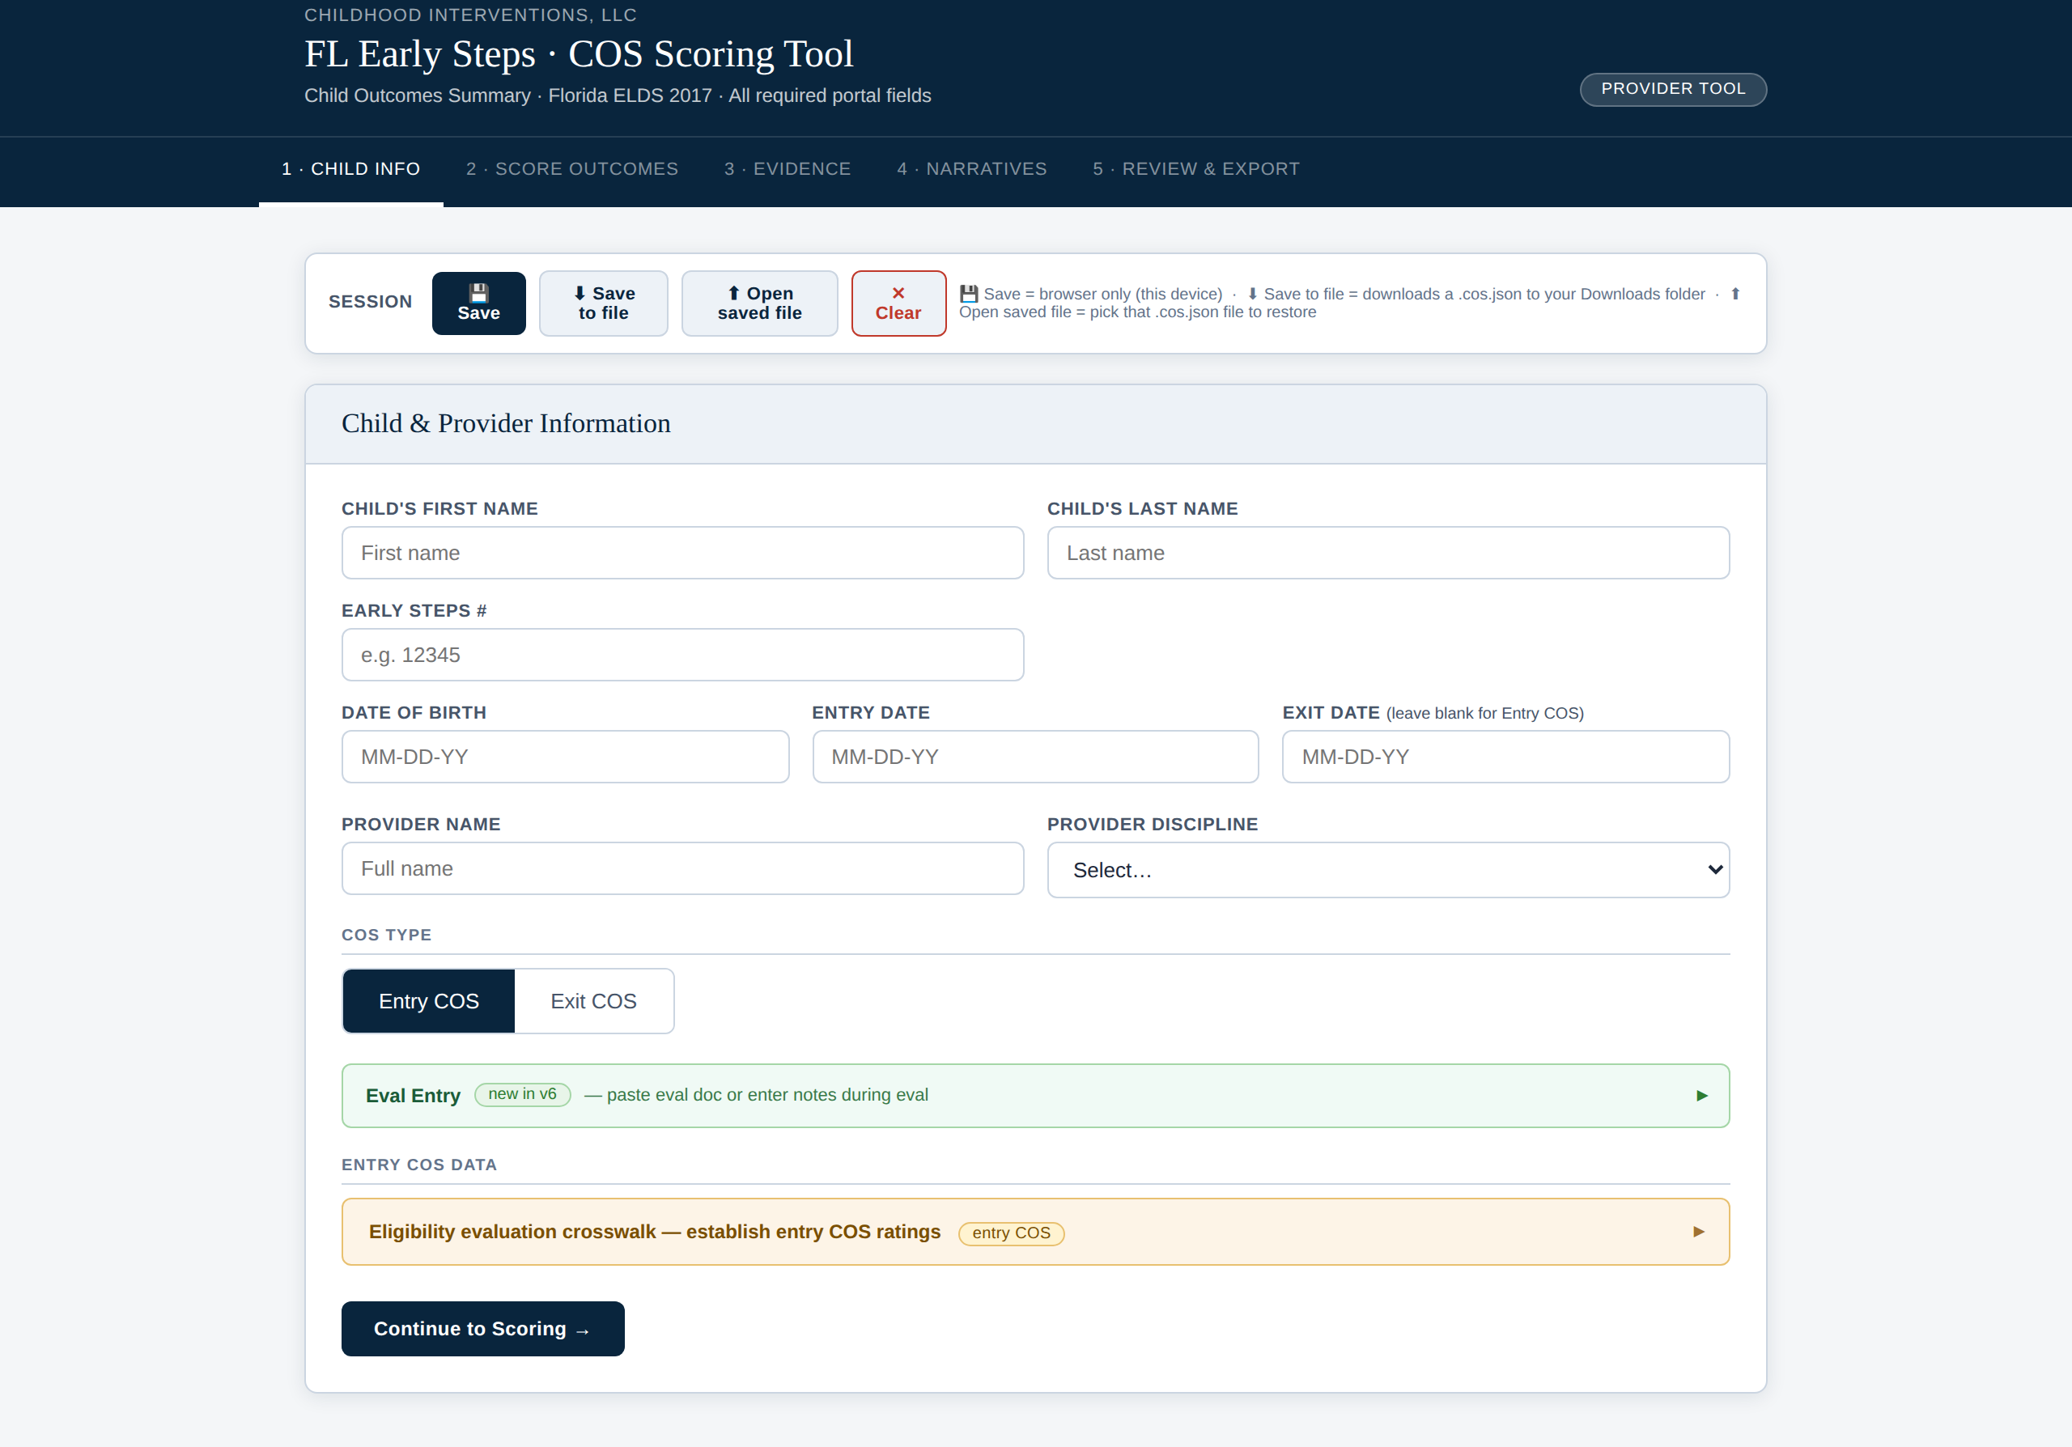
The COS workspace. The five-step tab bar (Child Info → Review & Export) runs across the top; the blue SESSION bar lets you Save, Save to file, or Open a saved file at any time.
1 | Select or add the child  Choose the child from your roster or add a new child record. Enter the child's initials (or first name only) and date of birth. The COS type (entry or exit) is selected here.

2 | Enter evidence for Outcome A  For the Social-Emotional outcome area, describe the child's current skills in natural environments. Note both strengths and areas of concern. More specific evidence produces better AI narratives.

3 | Review the recommended rating for Outcome A  You don't pick the rating from a blank slate — the tool generates a recommended 1–7 rating from the evidence (the eligibility crosswalk for an entry COS; your uploaded notes or the Yes/No skills checklist for an exit COS). Compare it to the on-screen 7-point scale, adjust it if the team's clinical judgment differs, and note the rating discussion if there is disagreement.

4 | Repeat for Outcomes B and C  Complete the same process for Knowledge & Skills (B) and Taking Action to Meet Needs (C). The tool steps you through each in sequence.

5 | Generate narratives and export  After all three outcomes are scored, click Generate Narratives to get AI-drafted summaries. Review, edit, and then export the complete COS as a PDF.

⚠️ Team consensus required: Florida Early Steps requires COS ratings to reflect team consensus. The tool supports documentation of the discussion, but the rating entered should reflect the full IFSP team's agreed-upon score — not one person's opinion.

📝 Entry COS example — Outcome A (Social-Emotional) Child: 18-month-old, referred for speech delay Evidence entered: "Child makes eye contact and smiles when greeted. Reaches up to be held and calms when comforted by familiar caregiver. Does not yet point to request items or show shared attention with objects. Parallel play observed — does not initiate joint play with peers." Rating selected: 3 — Child shows some foundational skills (emotional reciprocity, attachment) but lacks key age-expected skills (joint attention, intentional communication, peer engagement). AI-generated narrative: "At entry, [child] demonstrates emerging social-emotional skills consistent with a rating of 3. Strengths include appropriate emotional reciprocity and caregiver attachment. Joint attention and intentional social communication are not yet present at age-expected levels and represent priority areas for early intervention."

🏁 Exit COS
An exit COS is completed when a child transitions out of Early Steps — either at age 3 or when services are discontinued. The exit COS is compared to the entry COS to calculate the federal progress indicator (a, b, or c) for each outcome area.
💡 Progress indicator is automatic — when entry ratings are on file: When you select "Exit" as the COS type, the tool loads the child's entry ratings and calculates the progress indicator once exit ratings are set — no manual calculation. This requires the entry ratings to be available (loaded from the Entry COS save file or entered under Entry COS Data); if they aren't on file, provide them first.

1 | Select the child and choose "Exit" as the COS type  Setting the type to Exit loads the child's entry ratings (from the Entry COS save file or Entry COS Data) so the tool can compute the progress indicator. From here the tool will generate a recommended exit rating for each outcome from your documentation — you review and adjust rather than scoring from scratch.

2 | Drop in session notes or progress summaries  Use the drop zone below to drag and drop session notes, progress summaries, or evaluation reports. The AI reads these documents to help generate evidence-based exit narratives — saving you from rewriting what's already documented.

3 | Review the recommended rating for each outcome  For each of the three outcomes, the tool generates a recommended 1–7 rating from your uploaded notes (and the skills checklist, if you use it), shown next to the entry rating for comparison. Review each recommended rating, adjust it to reflect the team's consensus, and add any evidence not captured in the uploaded notes.

4 | Generate exit narratives and progress indicators  Click Generate Narratives. The AI uses your uploaded notes, entered evidence, entry ratings, and exit ratings to produce a narrative that describes growth since enrollment. Progress indicators (a, b, c) are calculated and included in the export.

📊 Progress indicator key: a — Child did not show or showed less growth than same-age peers b — Child showed growth but did not reach age expectations c — Child reached or surpassed age-expected skills

🤖 AI-Generated Narratives
Once ratings are complete, the tool uses the evidence you entered to draft supporting narrative language for each outcome area. These narratives explain the rating and can be included in IFSP documentation.
⚠️ Always review AI-generated narratives. The AI drafts language based on your evidence entries — but you must verify that the narrative accurately reflects the child's skills, your team's discussion, and the rating chosen. Edit anything that doesn't match.

- ✏️ Fully Editable — Click into any narrative to edit. Your changes are preserved as you move between sections.
- 🔄 Regenerate Anytime — Not happy with the draft? Click Regenerate on any outcome area to get an alternative version. Prior versions are not saved — copy before regenerating if you want to keep a draft.
📈 Tracking Progress Over Time
For children who have a prior COS on file, the tool can display entry ratings alongside current ratings to document progress. The federal progress indicator is calculated automatically.
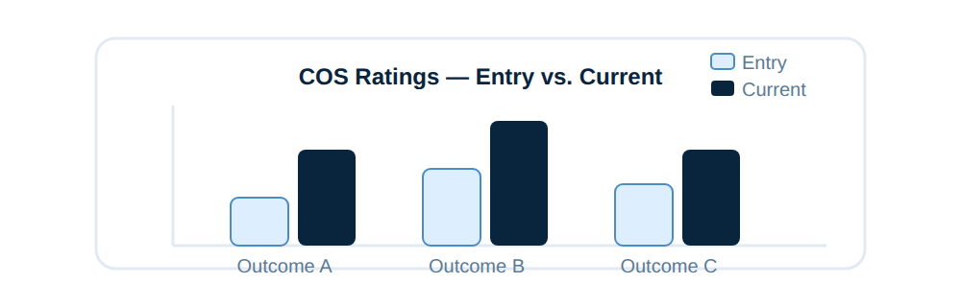
Workflow overview.
💾 Saving & Exporting
What | Where stored | PHI?
Child records & ratings | Secure cloud (shared roster with Session Notes) | Yes
In-progress COS drafts | Cloud — auto-saved as you progress | Yes
Completed COS (.docx) | Your device (Download Completed COS) — or Google Drive (Save to Drive) | Yes
Save to Drive | Google Drive: [child] ▸ COS (shared-drive layout below) | Yes
AI narratives | Not stored server-side — only in your session | Redacted

All three provider tools now save to one shared Google Drive, organized by child — so a child's session notes, COS documents, and reviews live together in the same place:
Tool | Saves to (in the shared Google Drive)
Session Notes | Session Notes (shared drive) ▸ [child] ▸ Session Notes ▸ <date>_session.pdf
COS | Session Notes (shared drive) ▸ [child] ▸ COS ▸ COS_<name>_<type>_<date>.docx
Review | Session Notes (shared drive) ▸ [child] ▸ Review ▸ <YYYY-MM> ▸ <child>_progress_summary.docx

☁️ Save to Drive: Click Save to Drive on the Review & Export screen to file the completed COS .docx straight into the child's COS folder in the shared Google Drive. The file is named COS_<name>_<type>_<date>.docx.

📥 Or download to your device: Click Download Completed COS (.docx) on the finalize screen. The document includes all three outcome ratings, the progress indicator, narratives, evaluator information, and date. Store any local copy in a HIPAA-compliant location and provide a copy to the IFSP team as required by your program.

🔐 HIPAA & Privacy
🛡️ COS data is Protected Health Information (PHI) COS ratings linked to a specific child constitute PHI under HIPAA. All data is stored in encrypted cloud storage keyed to your login. Access is controlled by your Provider Hub account credentials. Childhood Interventions operates under HIPAA as your Business Associate.

- 🔑 Account-Locked Storage — COS data is stored under your account only — no other provider or organization can access it.
- 🤖 AI & PHI Handling — Evidence descriptions are sent to the AI for narrative generation. Use functional descriptions rather than full child names or identifying details in evidence fields.
- 🌐 Encrypted Connections — All data between your browser and our servers is transmitted over encrypted HTTPS connections.
Best practices:
- Use the child's initials rather than full name in evidence fields when possible.
- Lock your device when stepping away during a COS session.
- Export PDFs only to HIPAA-compliant storage (organizational secure drive, not personal cloud).
- Notify privacy@childhoodinterventions.com of any suspected unauthorized access.

