CHILDHOOD INTERVENTIONS, LLC
USER GUIDE
EI Everywhere Library
243 family-facing activity cards for toddlers with developmental differences — no login required, free to share.
📚 243 Cards 🆓 Free Access 👨‍👩‍👧 Family-Facing 🌐 No Login
🛡 HIPAA Compliance & Data Privacy
Tools that handle Protected Health Information (PHI) operate under a Business Associate Agreement (BAA) with Childhood Interventions, LLC. This guide includes a dedicated HIPAA & Privacy section explaining exactly where your data is stored and what leaves your browser. Never store PHI in personal cloud storage (iCloud, personal Google Drive, personal Dropbox) without a BAA in place.

In this guide
- Overview
- Browsing the Library
- Filtering & Searching
- Sharing with Families
- Printing Cards
- Privacy & HIPAA
- Tips for Providers

📚 Overview
The EI Everywhere Library is a free, publicly accessible collection of 243 family-facing activity cards designed for toddlers with developmental differences. Each card describes a practical activity a caregiver can do at home — in everyday routines — to support their child's development.
As an Early Steps provider, you can share these cards directly with families during sessions, send the link as a home program resource, or browse them yourself to find carryover activity ideas for your coaching conversations.
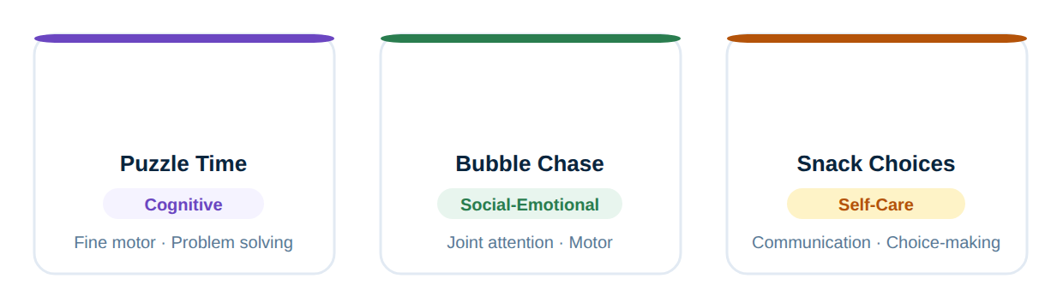
Workflow overview.
🆓 No login required. The EI Everywhere Library is completely free and open — anyone with the link can browse and use the cards. There is no PHI involved. Share the link freely with families, colleagues, or community partners.

- 🃏 243 Activity Cards — A large, curated collection covering all developmental domains — not a generic list, but activities designed specifically for toddlers with developmental differences.
- 🏠 Routine-Based — Every card is embedded in a natural daily routine — mealtimes, bath, play, bedtime — so families can practice without extra prep time.
- 🌍 Plain Language — Written for caregivers, not clinicians. No jargon — families can read and use each card independently, without needing a provider present.
- 📱 Mobile-Friendly — Works on any device — phone, tablet, laptop. Families can bookmark it on their phone for easy access throughout the day.
🔎 Browsing the Library
The library opens to a grid of all 243 cards. Cards show the activity title, a domain tag (e.g., Language, Motor, Social-Emotional), and a brief description of what the activity targets.
1 | Open the library  Go to ei-everywhere-library.vercel.app or click EI Everywhere Library from the Provider Hub dashboard. No sign-in required.

2 | Scroll the card grid  All 243 cards are displayed in a scrollable grid. Each card shows the activity emoji, title, developmental domain, and sub-skill tags at a glance.

3 | Click a card to open it  Clicking a card opens the full activity — including step-by-step instructions written for caregivers, materials needed (usually none), and tips for modification if the child is not yet ready for the full activity.

🔧 Filtering & Searching
With 243 cards, filtering helps you find the right activity for a specific child or goal quickly.
- 🏷️ Filter by Domain — Use the domain filter buttons at the top to show only cards in a specific area: Language, Social-Emotional, Motor, Cognitive, or Self-Care.
- 🔍 Search by Keyword — Type a keyword (e.g., "mealtime," "imitation," "bath") in the search box to find cards matching that term in the title or description.
- 🎂 Filter by Age Range — Select an age range to show only developmentally appropriate cards for a child of that age — useful when selecting home program activities.
- 🏠 Filter by Routine — Browse by daily routine (mealtime, playtime, bath, bedtime, getting dressed) to find activities that fit naturally into a family's existing schedule.
📤 Sharing with Families
The library is designed to be shared directly with families. Because there's no login required and no PHI involved, it's safe to share the link with any family.
🔗 | Share the library link  Share ei-everywhere-library.vercel.app with families via text, email, or your messaging platform. Families can bookmark it on their phone for ongoing access.

📋 | Share a specific card link  When viewing an individual card, the URL in the address bar is a direct link to that card. Copy and share it to send a family to a specific activity you've selected for them.

🖨️ | Print for families without devices  Each card has a print-friendly format. Open the card, click Print, and give the printed card to families who prefer paper materials.

💡 Use during coaching sessions: Browse the library with a caregiver during a visit to find activities they feel comfortable trying. Let the caregiver choose from a few options — it increases buy-in and home practice completion.

🖨️ Printing Cards
Any card in the library can be printed for families who prefer physical handouts.
🖨️ How to print: Open the card you want to print. Use your browser's print function (Ctrl+P / Cmd+P) or click the Print button on the card. Select "Save as PDF" if you want to email the card instead of printing it. Cards are formatted for a single page.

ℹ️ Printed and downloaded cards are free to share with families. They may not be modified, repackaged, or sold. © Childhood Interventions, LLC. All rights reserved.

🔐 Privacy & HIPAA
🛡️ No PHI is collected or stored by this tool. The EI Everywhere Library does not require a login, does not collect any user data, and does not store any information about which families or children access it. There is no PHI involved — you can share this tool with families without any HIPAA considerations.

- 🍪 No Tracking Cookies — The library does not use advertising cookies, tracking pixels, or analytics that identifies individual users.
- 🔒 HTTPS Served — The library is served over HTTPS — the connection between families and the site is encrypted.
- 👁️ No User Accounts — No accounts, no emails, no passwords. Families visit and browse — no data is created or stored about them.
💡 Tips for Providers
- 🎯 Connect cards to IFSP goals — When selecting cards for a family, choose activities that map to the child's active IFSP outcome areas so home practice directly supports documented goals.
- 📅 Assign 2–3 cards per visit — Research shows families are more likely to follow through with a small number of specific activities. Choose 2–3 cards per visit rather than a long list.
- 📸 Ask families to send updates — Encourage families to text a photo or short video of trying an activity. It drives carryover and gives you clinical data for your next session note.
- 📚 Use alongside FL-EPIC — The EI Everywhere Library pairs well with the FL-EPIC Session Guide — use FL-EPIC to structure your coaching framework and library cards as the specific activities within that framework.

