CHILDHOOD INTERVENTIONS, LLC
USER GUIDE
Provider Hub
Your single sign-in home for every Childhood Interventions tool — plus the admin panel for adding providers and managing their access.
🔐 One Sign-In 🚀 Launch Any Tool 👥 User Management 📖 Guide Library
🛡 HIPAA Compliance & Data Privacy
Tools that handle Protected Health Information (PHI) operate under a Business Associate Agreement (BAA) with Childhood Interventions, LLC. This guide includes a dedicated HIPAA & Privacy section explaining exactly where your data is stored and what leaves your browser. Never store PHI in personal cloud storage (iCloud, personal Google Drive, personal Dropbox) without a BAA in place.

In this guide
- Overview
- Signing In
- Your Dashboard
- Launching Tools
- Staying Signed In
- Admin: Managing Users
- Onboarding a Provider
- Access & Privacy

🧭 Overview
The Provider Hub is the front door to your Childhood Interventions tool suite. You sign in once at tools.childhoodinterventions.com and every tool your plan includes appears on one dashboard — one click to launch, with your identity carried through automatically. Providers never juggle separate logins for the COS Tool, Reviews, Session Notes, Management, and the resource libraries.
Administrators use the same Hub to add new providers, set which tools each person can open, reset passwords, and look up account status — all from a built-in admin panel.
- 🔐 Single sign-in — One email and password unlocks every tool in your plan. No separate accounts per tool.
- 🚀 One-click launch — Each tool opens in a new tab with your name and email passed through, so you skip re-entering them.
- 📦 Plan-based access — Only the tools included in your plan are launchable. Others are shown but locked.
- 📖 Guide library — The User Guides link in the top bar opens step-by-step guides for every tool.
- 👥 Admin panel — Add or update providers, set tool access, and reset passwords without leaving the browser.
- 🔎 User lookup — Check any provider's name, active status, tool access, and last login in seconds.
🔑 Signing In
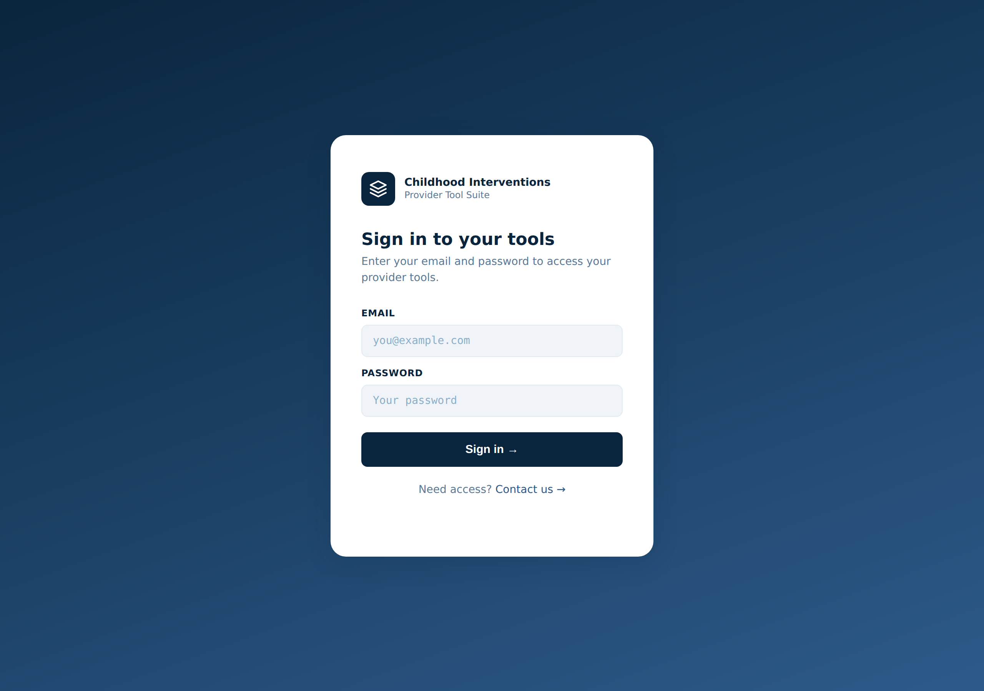
The Provider Hub sign-in. Enter the email and password for your account to reach your dashboard; the hub opens each tool with your license key already applied.
Providers sign in with the email and password an administrator set up for them.
1 | Go to the Hub  Open tools.childhoodinterventions.com in any browser. The sign-in screen appears.

2 | Enter your email and password  Use the email and temporary password your administrator sent you. Press Enter or click Sign in →.

3 | You land on your dashboard  Once signed in you see your tool cards. The Hub remembers you on this device, so you won't have to sign in every visit.

💡 Signed in on a shared or public computer? Use Sign out (top-right) when you're done so the next person can't reach your tools.

🔒 Forgot your password? There's no self-service reset. Email info@childhoodinterventions.com and an administrator will set a new one for you from the admin panel (see below).

🗂️ Your Dashboard
After sign-in the dashboard greets you by first name and groups your tools into three sections:
- 📝 Daily use — Session Notes, Provider Management, and the EI Everywhere Library — the tools you reach for most often.
- 🧮 Clinical documentation — The COS Scoring Tool and the Periodic / Annual Review Tool for IFSP-ready paperwork.
- 📋 Resources — The FL-EPIC Session Guide and other free, no-login reference materials.
A tool your plan includes shows a Launch ↗ button. A tool not in your plan appears dimmed with a 🔒 Not in your plan label — contact your administrator if you need it added.
📖 User Guides in the top bar opens the full guide library (this page lives there too) in a new tab, so you can look up how any tool works without leaving the Hub.

🚀 Launching Tools
Click Launch ↗ on any unlocked card and the tool opens in a new browser tab. The Hub passes your identity through so most tools recognize you without a second sign-in:
Tool | What the Hub passes through
COS Tool, Reviews | Your name and email, so the tool knows who you are for licensing.
Session Notes | A staff access key that unlocks the tool. You'll still approve a Google sign-in the first time (for saving notes to Drive).
Management, Library, FL-EPIC | Opens directly — these tools handle their own setup or need no login.

🪟 Tools open in a new tab, so the Hub stays open behind them. Switch back to the Hub tab any time to launch another tool.

🔄 Staying Signed In
The Hub keeps you signed in on the device and browser you used, so you land straight on your dashboard on your next visit — no re-typing your password each day. Your session is stored only in your own browser.
↻ | Switching devices  The Hub remembers you per-device. On a new phone or computer, sign in once with the same email and password.

⏻ | Signing out  Click Sign out in the top-right to clear your session on that device. Always do this on shared computers.

👥 Admin: Managing Users
Administrators manage every provider account from a built-in admin panel. It's protected by an admin secret — providers never see it.
🔐 Opening the admin panel: Add ?admin to the Hub URL — tools.childhoodinterventions.com/?admin — and the User Management screen appears. Every action asks for the admin secret; keep it private and never share it with providers.

Add or update a provider
1 | Enter the admin secret  Type your admin secret at the top of the User Management card.

2 | Fill in name, email, and a starting password  Enter the provider's full name and email, plus a temporary password they'll use for their first sign-in.

3 | Check the tools they should have  Tick the tools to grant: COS Tool, Reviews, Session Notes, Management, Library, and FL-EPIC Guide. Only checked tools will be launchable on their dashboard.

4 | Save and copy the handoff details  Click Add / Update User. A "Next steps" panel appears with the email and password to send the provider, plus their first-time setup checklist.

🔁 Resetting a password: Enter the provider's existing email, type a new password, and save. Their name and tool access stay exactly the same — only the password changes. To change tools without touching the password, leave the password field blank.

Look up a provider
Scroll to the Look up a user box, enter the admin secret and their email, and click Look up user. You'll see their name, whether the account is active, which tools they can access, and when they last logged in — handy for confirming a new provider signed in successfully or auditing who has access to what.
✅ Onboarding a Provider
The full path from "new hire" to "working in the tools" is short. After you add them in the admin panel, send the provider these steps:
1 | Sign in to the Hub  Go to tools.childhoodinterventions.com and log in with the email and temporary password you were sent.

2 | Approve the Google sign-in for Session Notes  The first time you open Session Notes, approve the Google sign-in popup so the tool can save notes to your Drive.

3 | Connect your spreadsheet  For Session Notes and Provider Management, copy the spreadsheet template you were given, then paste the sheet's URL when the tool asks for it.

4 | Read the tool guides  Open User Guides from the top bar for step-by-step help with each tool you'll use.

📋 The admin panel's "Next steps" panel shows this same checklist along with the provider's email and password after you add them — copy it straight into your welcome message.

🛡️ Access & Privacy
The Hub itself is a launcher and sign-in gate — it doesn't store clinical records. Here's what lives where:
Data | Where stored | PHI?
Your sign-in session | Your browser (localStorage) on your device only | No
Provider accounts (name, email, tool access) | The Hub's user store, behind the admin secret | No
Passwords | Stored securely by the Hub; never shown back in plain text | No
Child records, notes, billing (PHI) | Inside each individual tool — the Hub never sees them | Yes

🛡️ HIPAA Note: No Protected Health Information passes through the Hub. Child names, session notes, and billing data all live inside the individual tools and your own Google account — each covered by its own privacy and storage model, described in that tool's guide. The Hub only holds provider sign-in accounts (names, emails, tool access) so it can route the right people to the right tools.

