CHILDHOOD INTERVENTIONS, LLC
USER GUIDE
Provider Management
CONT billing, ESDS EMR & 837 claim upload, reconciliation, caseload tracking, and travel vouchers — all backed by your Google Sheet.
📊 Billing & Caseload 🧾 837 Claims 🔄 ESDS Reconciliation 🚗 Travel Vouchers 📅 Google Calendar
🛡 HIPAA Compliance & Data Privacy
Tools that handle Protected Health Information (PHI) operate under a Business Associate Agreement (BAA) with Childhood Interventions, LLC. This guide includes a dedicated HIPAA & Privacy section explaining exactly where your data is stored and what leaves your browser. Never store PHI in personal cloud storage (iCloud, personal Google Drive, personal Dropbox) without a BAA in place.

In this guide
- Overview
- Initial Setup
- ESDS 837 Claims (EMR + Claim Upload)
- ESDS Reconcile
- Caseload Tab
- Schedule & Calendar
- Logging Sessions
- Travel Vouchers
- Saving & Data

📊 Overview
Provider Management connects your Google Sheets billing spreadsheet to give you a live command center for your Early Steps practice. All your billing, scheduling, and caseload data lives in your own Google Drive — nothing is stored on our servers.
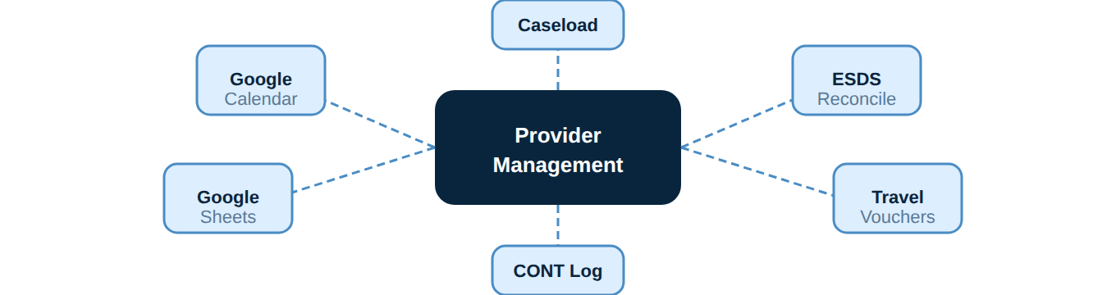
Workflow overview.
- 🧾 837 Claims (EMR upload) — Generate ESDS EMR contact notes and 837P claim files from logged sessions — new claims, replacements, voids, coordination of benefits, and batch files, proven end-to-end in ESDS.
- 🔄 ESDS Reconcile — Import a ClaimDetailExtract.xlsx from ESDS and instantly see what's changed, missing, or flagged — apply updates to your CONT tab in one click.
- 👨‍👩‍👦 Caseload — Track auth expiration dates, periodic and annual review due dates, and caregiver contact info for your entire active caseload.
- 📅 Weekly Schedule — Live calendar view pulled from Google Calendar — shows your current week with color-coded session status.
- 📝 Log Sessions — Log FLEPIC and EI session pairs directly to your CONT and Medicaid tabs in Google Sheets from within the app — no manual spreadsheet editing.
- 🚗 Travel Vouchers — Calculates mileage automatically from Google Calendar event locations. Supports chained trips when you drive session-to-session.
- ⚠️ Needs Attention — Surfaces unresolved, flagged, and rejected claims from your billing log so nothing slips through the cracks.
⚙️ Initial Setup
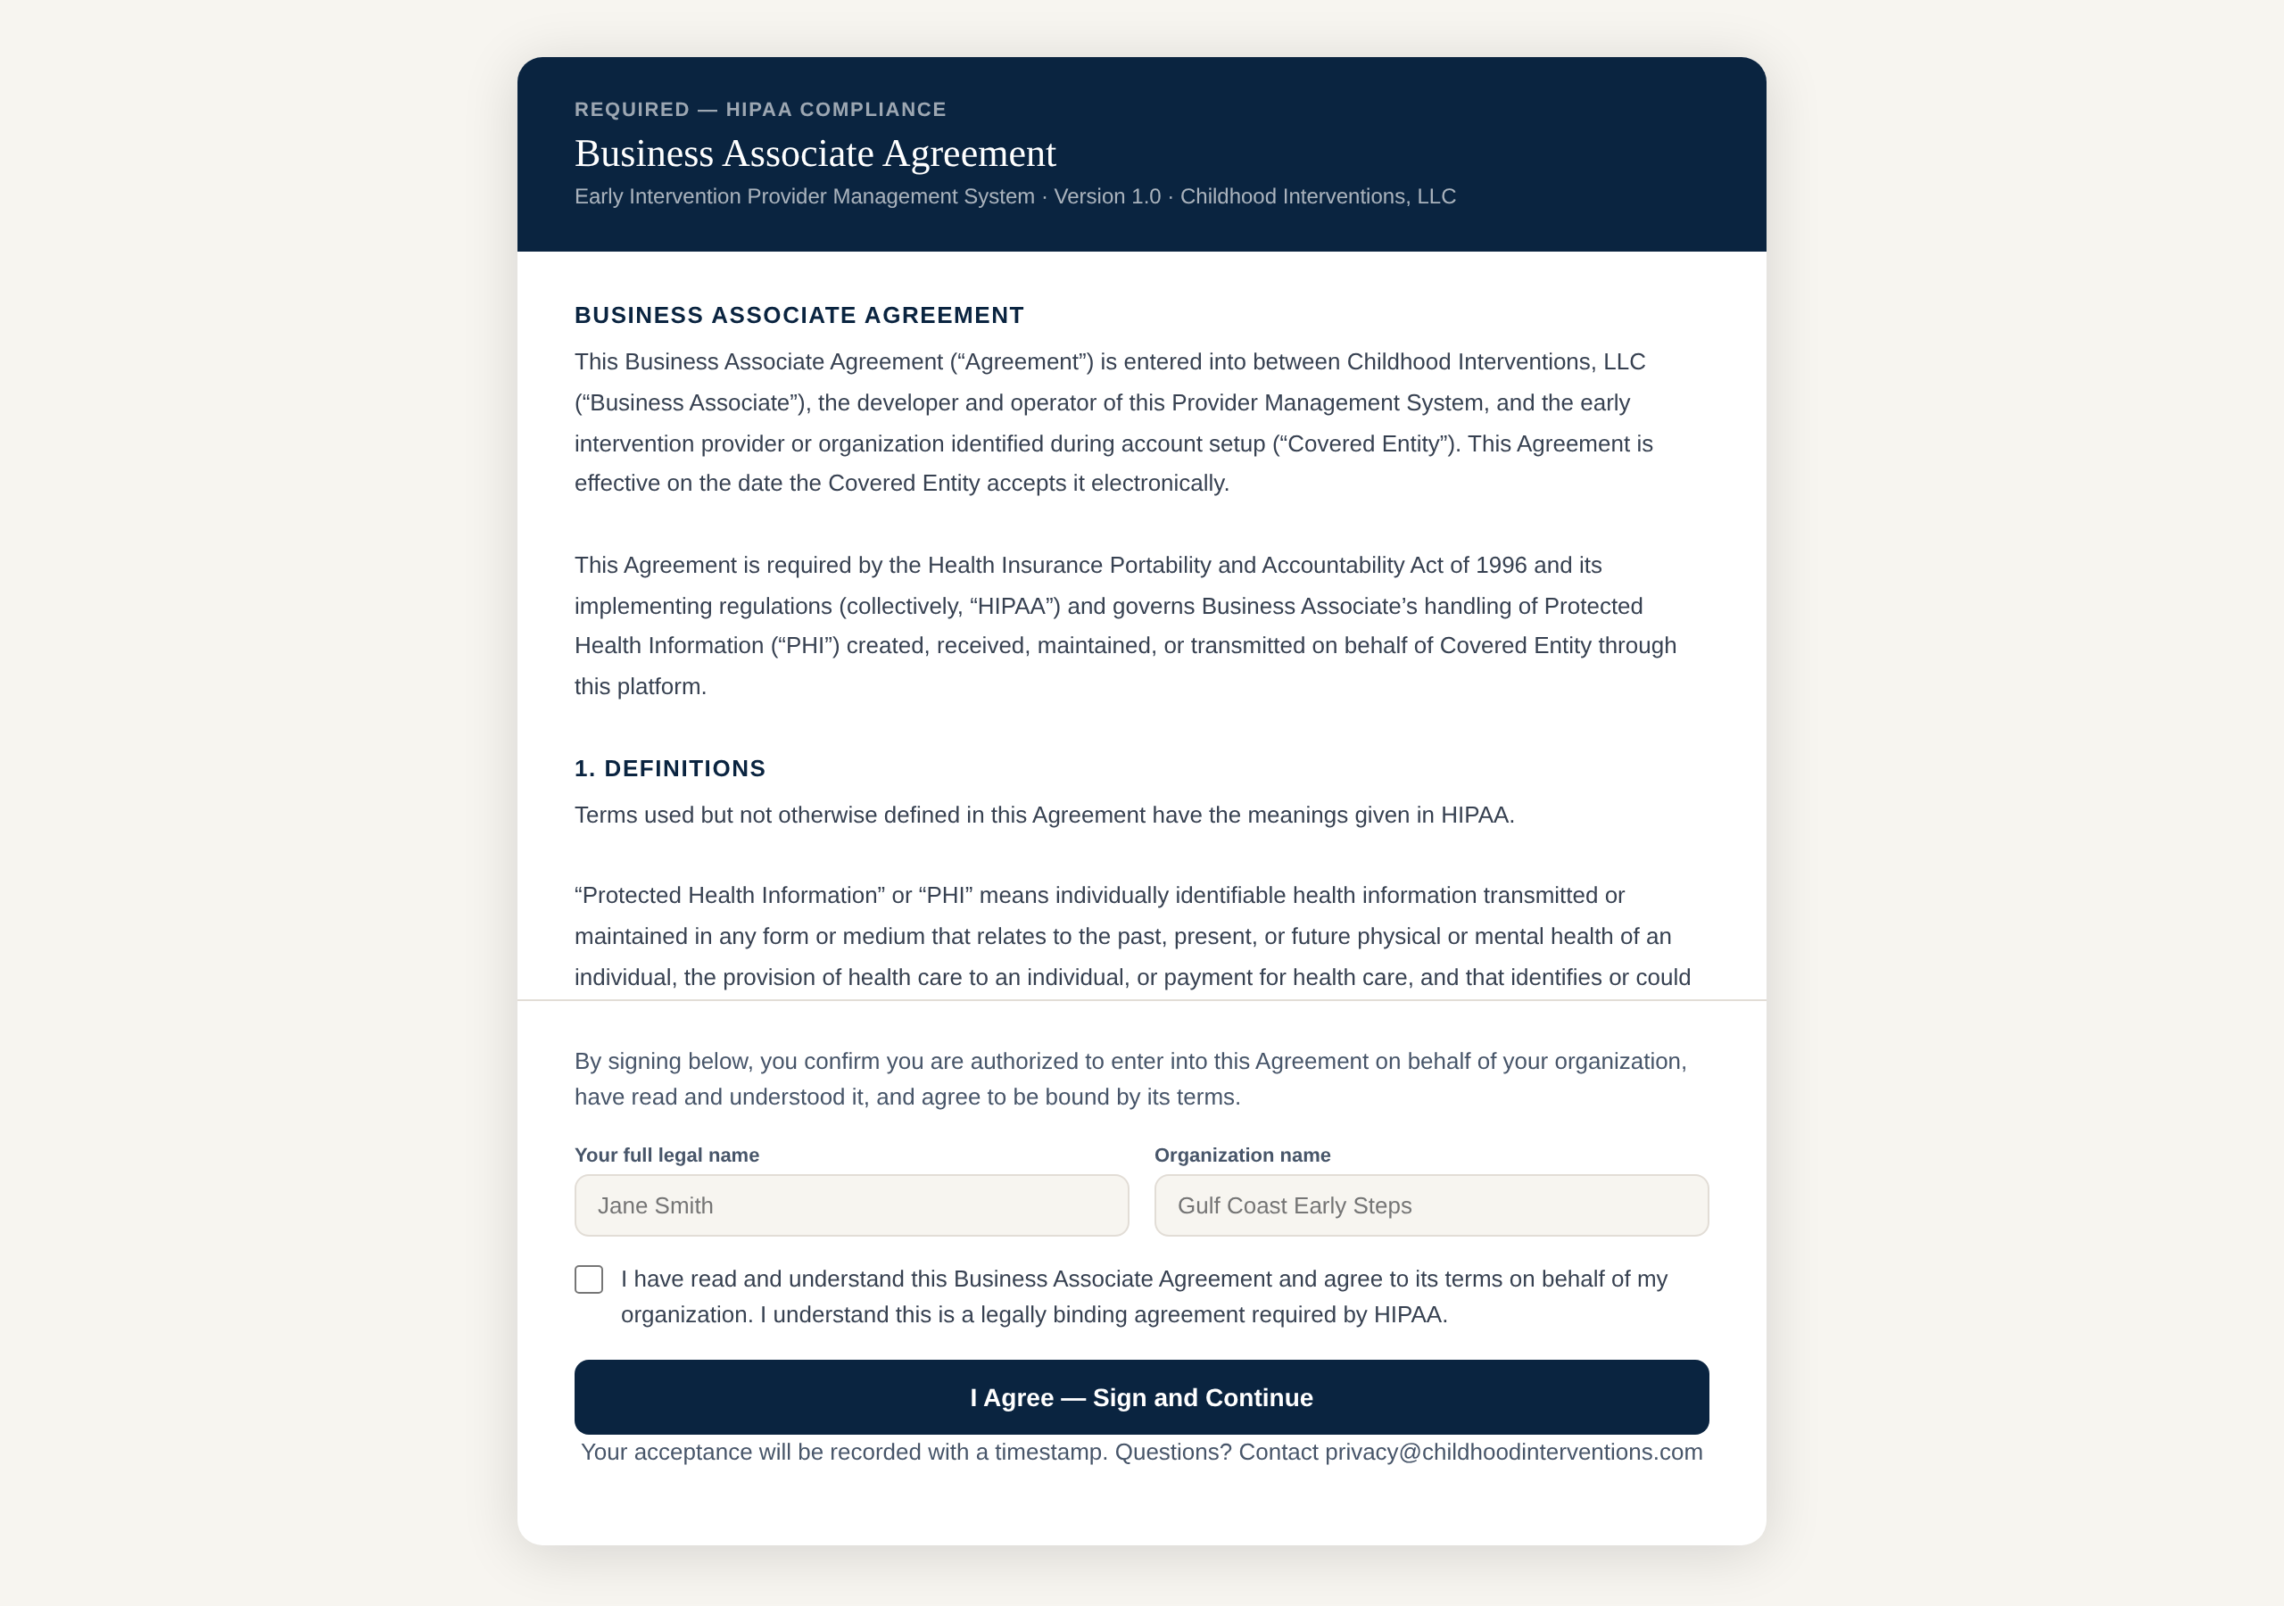
The Business Associate Agreement (BAA) shown on first launch. Enter your legal name and organization, check the box, and click “I Agree — Sign and Continue.” This is required by HIPAA and is only done once.
Provider Management connects directly to your Google Sheet via your Google account. Setup takes about two minutes — you only do it once.
📋 Before you begin: You need a copy of the Childhood Interventions spreadsheet template in your Google Drive. Contact info@childhoodinterventions.com if you haven't received it. The sheet must have tabs named: CONT, Ongoing, Humana, Sunshine, Simply, FCC.

1 | Copy the spreadsheet template to your Drive  Open the template shared with you and choose File → Make a copy. Save it to your own Google Drive. Do not work in the original shared file.

2 | Open Provider Management and sign in with Google  Open Provider Management from the Hub. A setup screen appears on first load. Click Sign in with Google and authorize access using the same Google account that owns your spreadsheet.

3 | Paste your Google Sheet URL  Open your copy of the spreadsheet in Google Sheets and copy the URL from your browser's address bar. Paste it into the Sheet URL field in the setup screen — it will look like https://docs.google.com/spreadsheets/d/…

4 | Fill in your details and click Get Started  Enter your name, discipline, home address (for travel mileage), and FLEPIC billing rate. Click Get Started — the app will load your caseload and schedule immediately.

🧾 ESDS 837 Claims (EMR + Claim Upload)
The 🧾 837 Claims tab turns your logged Part C (ITDS) sessions into the two files ESDS needs — the EMR contact note and the 837P claim file — and hands you exactly what to upload, in the right order. Every claim type an Early Steps provider needs is supported and proven end-to-end in ESDS: new claims, replacements, voids, coordination of benefits (secondary), and batch / master files.
🔑 The golden rule — three things must exist, in this order: (1) the child’s enrollment is active in ESDS, (2) an EMR contact note has been accepted so a Service Log exists, and (3) the 837 claim carries that Service Log ID. A claim with no matching service log is the most common rejection (“Enrollment and Service Log must be present”).

Step 1 — One-time: fill in 837 Setup
Open the 🧾 837 Claims tab and click ⚙ 837 Setup. These values go into every claim file, so you enter them once.
1 | Enter your ESDS-assigned IDs  Submitter / ETIN, Receiver ID, and ESDS Payer ID all come from the Early Steps Data System team. Set Environment to Test while validating and Production once ESDS confirms your files are accepted.
2 | Enter your organization details  Organization name, Organization NPI, Tax ID / EIN, billing taxonomy, address, and the ESDS Program # (your org number). Add a Submitter contact name and phone — ESDS rejects a file without a contact.
3 | List your rendering providers  One provider per line: Name | NPI | Taxonomy | Discipline | ESDS email. The discipline (ITDS, Speech, OT, PT) sets the CPT list and the ESDS login email identifies the clinician. Click Save setup.
⚠️ The ETIN is your Medicaid number. The Submitter / ETIN is not your business EIN and not your Provider ID — it is your organization’s Medicaid provider number. If a file returns “ETIN is missing or does not match,” this is almost always why.

Step 2 — Build your list of sessions
1 | Choose source, provider, and dates  Pick Part C · ITDS as the source, choose the rendering provider, and set the date range. Leave Unbilled only checked to hide sessions that already have a claim #. Click Refresh list.
2 | Check each row  Confirm the CPT, units, and place of service for each session (use Set all POS… to apply one to every row). Rows flagged ⚠ are missing an enrollment # or provider discipline. Tick Group for a group session (adds the TT modifier and child count).

Step 3 — Upload the EMR contact notes first
1 | Export the EMR contact notes  Click ⬇ EMR contact notes. This creates the ESDS EMR file that records each Part C session as a contact note.
2 | Upload it on the ESDS EMR Dashboard  In ESDS, upload the file on the EMR file upload / EMR Dashboard — not the 837 upload. ESDS creates a Service Log for each accepted note and returns a response (acknowledgement) file.
3 | Import the ESDS response  Download the ESDS response file, then click ⬆ Import ESDS response and select it. The tool shows what was accepted, lists any per-record errors to fix, and writes each returned Service Log ID back onto your CONT tab so the claim file can use it.
📁 Saving files on an iPad or phone: save the generated file straight to Files without previewing it first, and keep the exact name and extension (.xml for the EMR note, .837 for the claim). Previewing can re-encode the file and cause ESDS errors like “Content is not allowed in prolog” or “Error getting separators.”

Step 4 — Export and upload the 837 claim file
1 | Confirm each row has a Service Log ID  After the response import, each row’s Service Log ID is filled in. This is required — the claim cannot link to ESDS without it.
2 | Set the Claim action  In the Claim action column choose Original for a new claim; Replace to correct an accepted claim that paid wrong; or Void to cancel one. For Replace and Void, enter the original ESDS claim #. Use + COB when another payer paid first, and enter the primary payer and paid amount.
3 | Export the .837 file  Click ⬇ Export .837 file and upload it on the ESDS 837 upload. When ESDS accepts it the claim(s) are created — the returned claim # can then be reconciled with ESDS Reconcile.

What each claim action does
- 🆕 Original (new claim) — a first-time claim for a session; the default for anything not yet billed.
- ♻️ Replace — corrects an accepted claim that paid wrong (wrong units, rate, or code). Enter the original ESDS claim # so ESDS replaces it instead of duplicating.
- 🚫 Void — cancels an accepted claim entirely. Enter the original ESDS claim #.
- 🔗 Coordination of benefits — a secondary claim after another payer paid first. Add the primary payer’s name, member ID, and paid amount.
🛡️ HIPAA note: Both the EMR contact-note file and the 837 claim file are generated entirely in your browser and downloaded to your device — nothing is sent to Childhood Interventions servers. They contain PHI, so upload them directly to ESDS and delete the local copies when done.

🔄 ESDS Reconcile
The ESDS Reconcile tab is the fastest way to keep your CONT billing log in sync with ESDS claim statuses.
1 | Download ClaimDetailExtract.xlsx from ESDS  Log into ESDS, navigate to your claim reports, and export the ClaimDetailExtract file. This is the standard billing export format ESDS provides.

2 | Drop the file into the Reconcile tab  In Provider Management, click ESDS Reconcile in the sidebar. Drag-and-drop the .xlsx file onto the upload area, or click to browse.

3 | Review the diff  The app compares the ESDS data against your CONT tab and shows a color-coded list: new claims not in your sheet, status changes (e.g., approved → paid), and missing ESDS entries.

4 | Apply updates  Click Apply All Updates to write the reconciled statuses back to your CONT tab in Google Sheets. Review each change if you prefer — you can apply selectively.

👨‍👩‍👦 Caseload Tab
The Caseload tab pulls from your Ongoing sheet tab and gives you a live dashboard of every active child — sorted by urgency.
- 📅 Auth Expiration Tracking — Auth end dates are color-coded — red for expiring within 30 days, yellow for 60 days. Never let an auth lapse by surprise.
- 🗓️ Review Due Dates — Periodic and Annual review due dates are calculated and displayed for each child so you can plan ahead for IFSP meetings.
- 📞 Caregiver Contact — Caregiver name, phone, and email are displayed per child — tap to call or email directly from your mobile browser.
📅 Schedule & Calendar
The Schedule tab shows your current week pulled live from Google Calendar. Sessions are color-coded by status.
💡 The calendar reads from the Google account that owns your linked spreadsheet. Use the same calendar for all Early Steps sessions so all events appear here.

📝 Logging Sessions
Use Add Session or Log Session to record FLEPIC and EI session pairs directly into your CONT and Medicaid tabs without opening Google Sheets.
1 | Open Add Session  Click Add Session in the sidebar. Select the child from your caseload list or enter their name and auth number manually.

2 | Fill in session details  Enter the session date, duration, session type (FLEPIC or EI), location, and billing codes. Both FLEPIC and EI entries for the same visit can be logged together.

3 | Submit  Click Log Session. The app writes the new row(s) directly to your CONT and Medicaid tabs. You'll see a confirmation when it's saved.

🚗 Travel Vouchers
The Travel Voucher feature auto-calculates mileage from your Google Calendar event locations and generates a printable voucher at the Florida Early Steps reimbursement rate (44.5 cents/mile).
1 | Ensure Calendar events have addresses  Travel is calculated from the Location field of each Google Calendar event. Add the full street address of each session location to your calendar events for accurate mileage.

2 | Open the Travel Voucher tab and select a date range  Choose the pay period you're vouching for. The app reads your calendar events for that range and maps each trip from your home (or prior session location for chained trips).

3 | Review calculated miles and generate the voucher  Review the trip list, adjust any legs if needed, then click Generate Voucher. A printable PDF is created showing each trip and the total reimbursable amount.

🔗 Chained trips: If you drove directly from one session to the next (without returning home), the app calculates mileage from the first session address to the next — not from your home — so you aren't credited for mileage you didn't drive.

💾 Saving & Data
Provider Management is a read/write bridge between this app and your Google account. Here's exactly where each piece of data lives:
Data | Where stored | PHI?
Sheet ID, name, discipline, home address, billing rate | Your browser (localStorage) | No
Caseload / Ongoing data | Your Google Sheet (Ongoing tab) | Yes
CONT billing log | Your Google Sheet (CONT tab) | Yes
Calendar events | Your Google Calendar | Yes
ESDS reconcile file | Local browser memory only (not saved) | Yes
Service Log IDs (from EMR response) | Your Google Sheet (CONT tab, column N) | No
EMR contact-note & 837 claim files | Generated in your browser, downloaded to your device | Yes
Travel voucher PDF | Your device (download) | No

🛡️ HIPAA Note: All PHI (child names, dates, billing data) is stored in your own Google account — not on Childhood Interventions servers. Google Workspace for Healthcare can be used under a Google BAA if your organization requires it. The app connects directly to your Google Sheet using the URL you provide — no data is stored or proxied through our servers. The ClaimDetailExtract file you upload is processed entirely in your browser and is never transmitted to our servers.

