CHILDHOOD INTERVENTIONS, LLC
USER GUIDE
Periodic & Annual Review Tool
Upload session notes and generate IFSP-ready progress summaries by outcome area — powered by AI, with PHI redacted from AI processing.
📋 IFSP Reviews 🤖 AI-Powered 🔒 PHI Redacted 🌐 Browser-Based
🛡 HIPAA Compliance & Data Privacy
Tools that handle Protected Health Information (PHI) operate under a Business Associate Agreement (BAA) with Childhood Interventions, LLC. This guide includes a dedicated HIPAA & Privacy section explaining exactly where your data is stored and what leaves your browser. Never store PHI in personal cloud storage (iCloud, personal Google Drive, personal Dropbox) without a BAA in place.

In this guide
- Overview
- Accessing the Tool
- Uploading Session Notes
- Generating Summaries
- Outcomes, Goals & Strategies
- Outcome Areas
- Editing & Finalizing
- Saving & Exporting
- HIPAA & Privacy

📋 Overview
The Periodic & Annual Review Tool takes the most time-consuming part of an IFSP review — writing progress summaries — and turns it into a guided, AI-assisted process. Upload the session notes from the review period, and the tool generates a narrative summary for each of the three IFSP outcome areas.
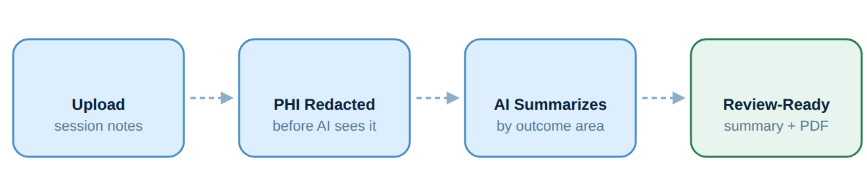
Workflow overview.
The tool organizes generated content around the three federal IFSP outcome areas (A, B, C) so the summaries are ready to paste directly into IFSP review documentation.
🔑 Accessing the Tool
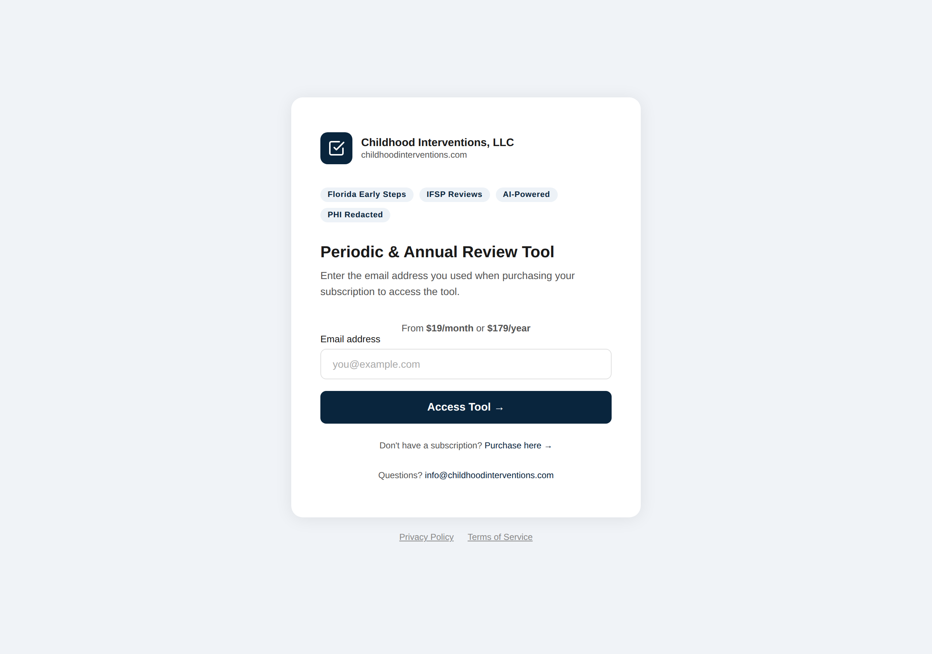
The Periodic & Annual Review Tool sign-in screen.
Access is provided through a subscription. The Periodic & Annual Review Tool is available from the Childhood Interventions Provider Hub at tools.childhoodinterventions.com.
1 | Sign in to the Provider Hub  Go to tools.childhoodinterventions.com, enter your email and password. Click Periodic / Annual Review from the dashboard — you'll be taken directly into the tool with your email pre-validated.

2 | Or access directly  Go to summaries.childhoodinterventions.com. Enter your subscription email on the login screen and click Access Tool →. Your email is validated against your active subscription.

💳 Subscription required. Purchase access at the link on the login page. Once purchased, your email address is activated within a few minutes. Contact info@childhoodinterventions.com if access isn't working after 15 minutes.

📤 Uploading Session Notes
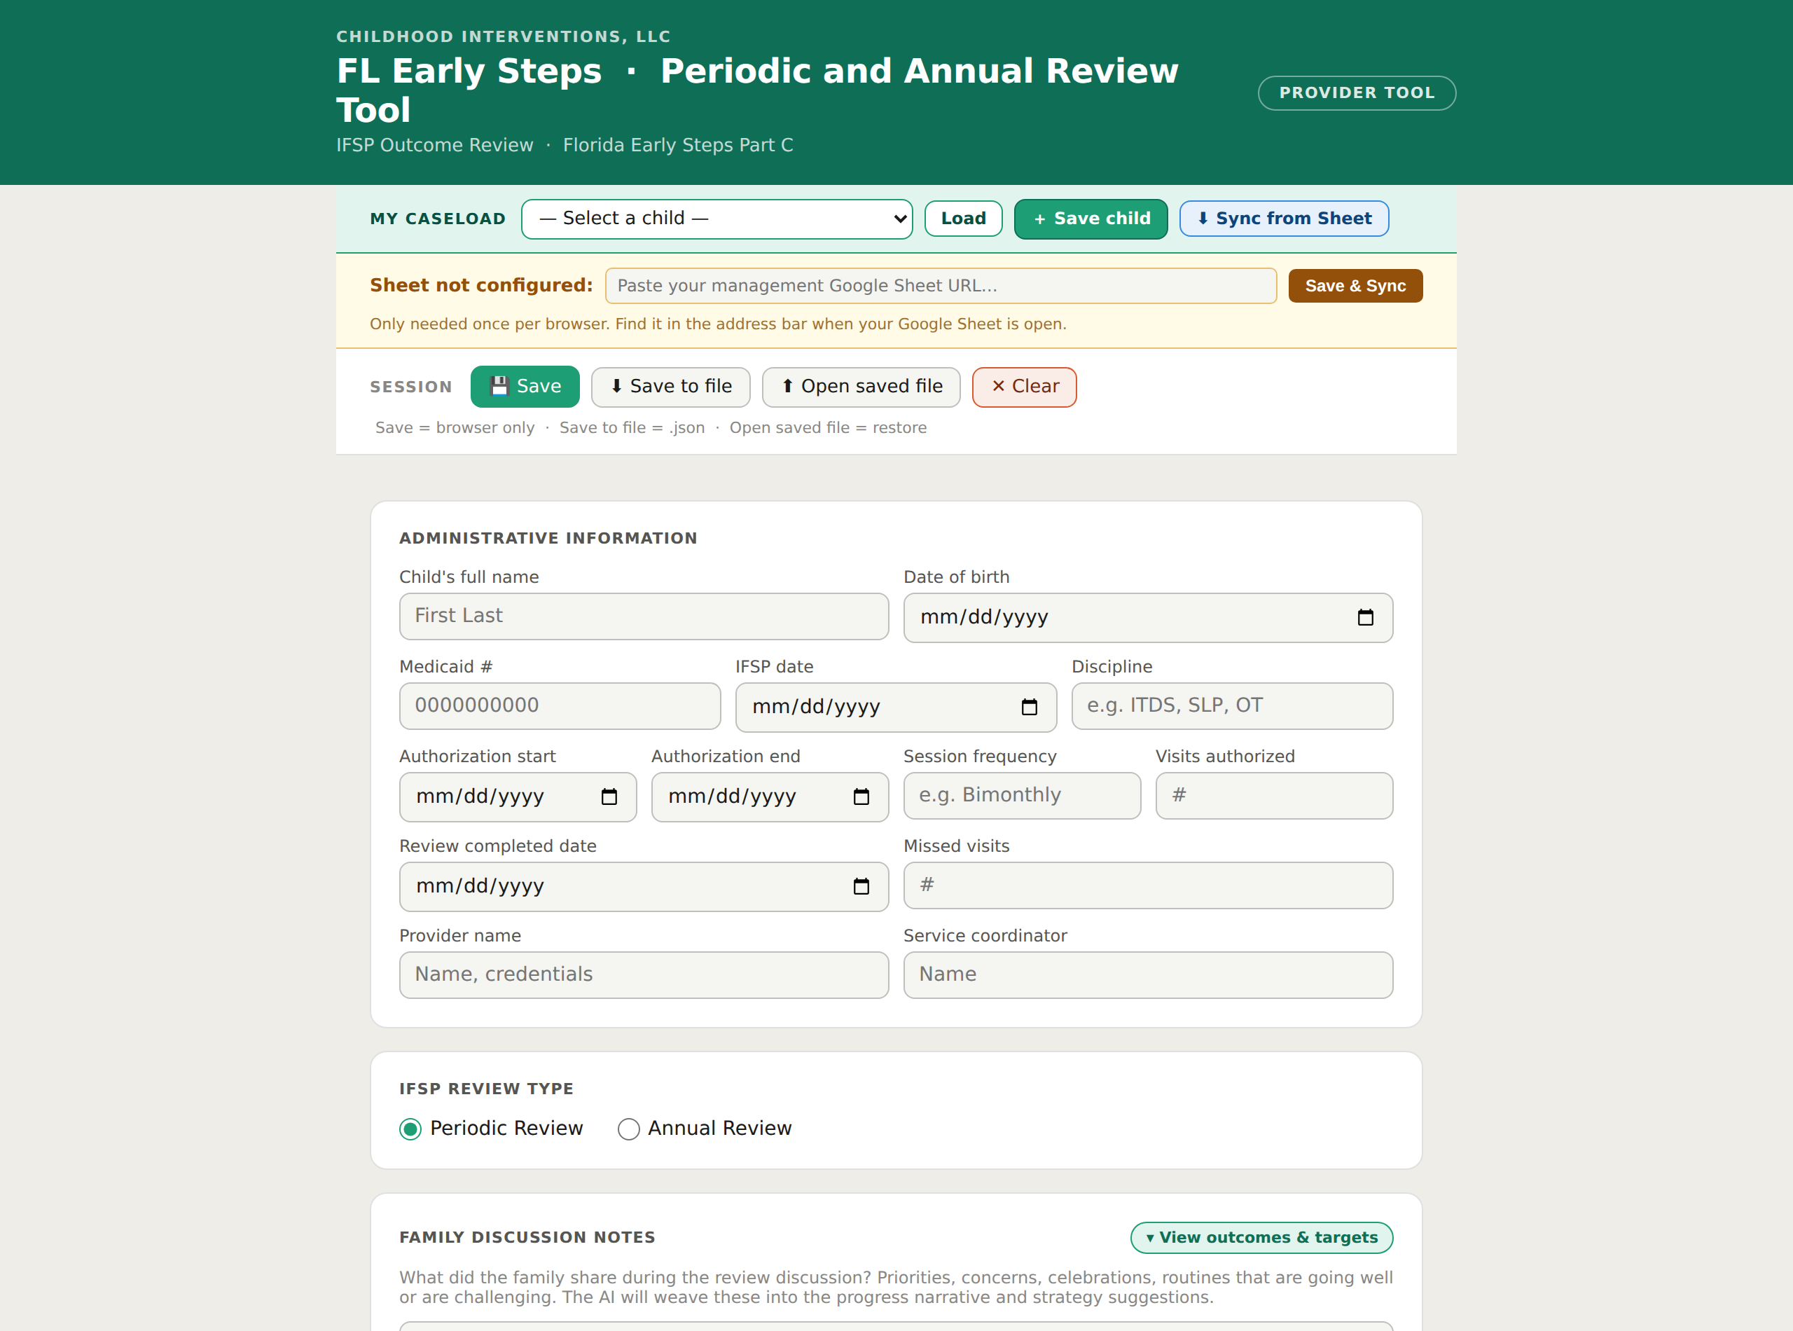
The review workspace: caseload picker and Google Sheet sync at the top, the SESSION save bar, and the Administrative Information panel below.
The tool accepts session notes in PDF or text format. You can upload multiple notes from the review period at once — the AI reads all of them to build the progress summary.
1 | Gather the session notes for the review period  Collect all completed session notes from the current IFSP period. These can be PDFs downloaded from EI Session Notes, scanned paper notes, or text documents. The more complete the notes, the better the summary.

2 | Drag and drop or browse to upload  On the main screen, drag your note files onto the upload area or click Browse files. Multiple files can be selected at once. Supported formats: PDF, DOCX, TXT.

3 | Enter review details  Enter the child's initials (not full name), date of birth, review period start and end dates, and any specific goals or outcomes to focus on. Use initials and dates — not identifying names.

⚠️ Use initials, not full names. Enter the child's initials (e.g., "J.S.") in the name field — not their full name. The tool redacts obvious identifiers before sending to AI, but minimizing PHI in input fields is best practice and your responsibility.

🤖 Generating Summaries
Once notes are uploaded, the AI reads through all of them and generates a progress narrative for each IFSP outcome area.
1 | Click "Generate Summary"  After uploading notes and entering review details, click Generate Summary. Processing typically takes 20–60 seconds depending on the number and length of notes.

2 | Wait for the progress indicator  A progress bar shows while the notes are processed. Do not close the tab — if you navigate away, you'll need to restart. The tool processes notes locally in your browser before sending anonymized content to the AI.

3 | Review the generated summaries  Three summary sections appear — one per IFSP outcome area. Each is an editable text block. Read each carefully before use.

🧩 Outcomes, Goals & Strategies
The Review Tool doesn't just narrate progress — it works with the child's actual IFSP outcomes and their benchmarks (goals), proposes strategies for the next review period, and can even draft a brand-new outcome. These features are easy to miss, so here is what each one does:
- Enter the child's IFSP outcomes & benchmarks. In the IFSP outcomes & benchmarks card, click ＋ Add outcome for each current IFSP outcome. Type the outcome statement and its 3-month and 6-month benchmarks (the goals/targets), one per line. The AI reports progress against exactly these targets — so the more accurately you enter them, the better the summary. Use View outcomes & targets to double-check what you entered.
- Generate strategies for the next 6 months. After you generate the summary, the tool proposes Strategies to support progress over the next 6 months. Turn on the routines-based option to anchor each strategy to a daily routine (bath, meals, play, bedtime, outings), and/or Draw from the EI Everywhere library for additional ideas. Select or deselect individual strategies, click ＋ Give me more strategies for extras, and Copy strategies when you're done.
- Create a new outcome — with benchmarks and targets. Need an outcome that isn't in the current IFSP yet? Use ✦ Generate additional outcome: paste or describe the outcome and enter its 3-month and 6-month benchmarks (one target per line). The AI drafts a full outcome — narrative, benchmarks, and new targets — for you to review and add.
🔐 Use initials — this tool sees the most PHI. Because you paste real session-note text and IFSP outcomes here, this is the tool where identifying information is most likely to slip in. Enter the child's initials only (never full name), and leave out dates of birth, addresses, and Medicaid numbers — the content is sent to the AI to generate the summaries and strategies.

🎯 Outcome Areas
The tool generates a progress narrative for each of Florida's three IFSP outcome areas, aligned with ESDS documentation requirements.
- 💛 Outcome A — Social-Emotional — Summarizes progress in positive social relationships, emotional regulation, and social communication with peers and adults.
- 📘 Outcome B — Knowledge & Skills — Documents acquisition of concepts, vocabulary, early literacy/numeracy, problem solving, and imitation from the review period notes.
- 💚 Outcome C — Meeting Needs — Covers the child's ability to take care of basic needs: feeding, dressing, mobility, safety, and communicating wants and needs.
💡 COS rating connection: Progress summaries generated here can also be used as source material when completing a Child Outcome Summary (COS) rating in the COS Scoring Tool. Both tools are designed to work together in your IFSP review workflow.

✏️ Editing & Finalizing
AI-generated summaries are a starting point — always review and personalize before using in official documentation.
⚠️ Review all generated text before use. AI can miss context, misinterpret clinical language, or generalize incorrectly. You are the clinician of record — the final summary is your professional statement and must reflect your accurate clinical judgment.

✏️ | Click into any summary block to edit  Each outcome area is an editable text field. Click directly into the text to make changes. Your edits are not auto-saved — copy your final text or use the export function before closing.

🔄 | Regenerate if needed  If a section doesn't capture the right themes, you can regenerate individual sections or all three. Each regeneration may produce slightly different language.

💾 Saving & Exporting
Finish a review by saving it — either to the shared Google Drive or to your device. The tool does not keep your summaries after you close the browser, so save before you leave.
What | How to save | Where it goes
Completed review (.docx) | Save to Drive | Google Drive: [child] ▸ Review ▸ [month-yr]
Completed review (.docx) | Download .docx | Your device
Summary text | Copy to clipboard | Paste into ESDS or your IFSP form
Uploaded note files | Not stored — processed in memory only | Never leave your browser session
Your subscription | Managed via email validation | Childhood Interventions servers (email only)

All three provider tools now save to one shared Google Drive, organized by child — so a child's session notes, COS documents, and reviews live together in the same place:
Tool | Saves to (in the shared Google Drive)
Session Notes | Session Notes (shared drive) ▸ [child] ▸ Session Notes ▸ <date>_session.pdf
COS | Session Notes (shared drive) ▸ [child] ▸ COS ▸ COS_<name>_<type>_<date>.docx
Review | Session Notes (shared drive) ▸ [child] ▸ Review ▸ <YYYY-MM> ▸ <child>_progress_summary.docx

☁️ Save to Drive: Click Save to Drive to file the completed review .docx into the child's Review ▸ [month-year] folder in the shared Google Drive (named <child>_progress_summary.docx). Prefer a local copy? Use Download .docx and store it in a HIPAA-compliant location — never in personal cloud storage (iCloud, personal Google Drive, Dropbox) without a BAA in place.

📋 Copy to IFSP documentation: You can also copy the text from each outcome area directly into your IFSP review form in ESDS or another system. The text is yours to use in any format your program requires.

🔐 HIPAA & Privacy
🛡️ PHI is redacted before AI processing Before any note content is sent to the AI, the child's name is replaced with initials and the Medicaid number with [ID-REDACTED] — both done locally in your browser. The tool does not store or retain session note content. Avoid pasting other identifiers such as caregiver names or addresses into session note fields.

- 📥 Notes stay in your browser — Uploaded session note files are read in your browser and never uploaded to our servers. The files go from your device to the AI — not through our storage.
- 🔐 Subscription auth only — The only data stored server-side is your email address and subscription status. No notes, summaries, or child data are ever stored on our servers.
- 🌐 HTTPS throughout — All connections are encrypted via HTTPS. Do not use the tool on public Wi-Fi without a VPN, as your screen content could be visible to others nearby.
Your responsibilities:
- Use initials only (not full child names) when entering review details.
- Only use the tool on a device with a screen lock and password protection.
- Export PDFs to HIPAA-compliant storage locations only.
- Do not share your subscription email/login with others outside your organization.
- Log out or close the browser tab when finished, especially on shared devices.

