EI Session Notes User Guide
AI-assisted, ESDS-compliant session notes with caregiver signature capture — built for Early Steps providers.
📝 Session Notes ✅ HIPAA Compliant 🔐 BAA Included 🤖 AI-Assisted
🛡 HIPAA Compliance & Data Privacy
Tools that handle Protected Health Information (PHI) operate under a Business Associate Agreement (BAA) with Childhood Interventions, LLC. This guide includes a dedicated HIPAA & Privacy section explaining exactly where your data is stored and what leaves your browser. Never store PHI in personal cloud storage (iCloud, personal Google Drive, personal Dropbox) without a BAA in place.

In this guide
- Overview
- Getting Started
- Writing a Session Note
- Caregiver Signatures
- Saving & Exporting
- HIPAA & Privacy
- Managing Your Roster
- Tips & Best Practices

📋 Overview
EI Session Notes is a browser-based tool that helps Early Steps providers write, complete, and store ESDS-compliant session notes faster — without sacrificing quality or compliance. The tool uses AI to draft note language based on your session inputs, then lets you review, edit, and finalize before generating a PDF.
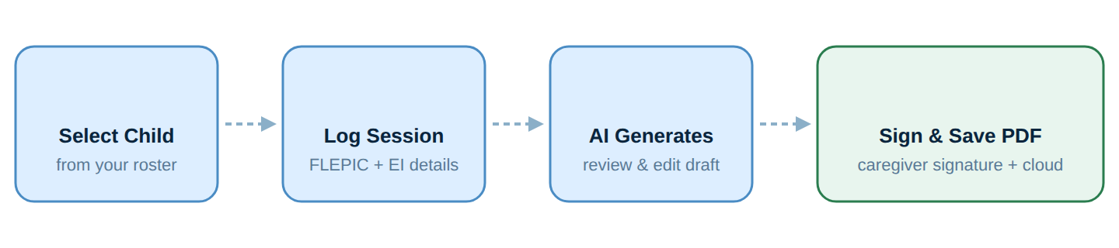
Workflow overview.
- 🤖 AI-Assisted Drafting — Enter session details and the AI generates ESDS-compliant note language for you to review and edit.
- ✍️ Caregiver Signatures — Capture a digital caregiver signature directly in the browser — no paper or separate app needed.
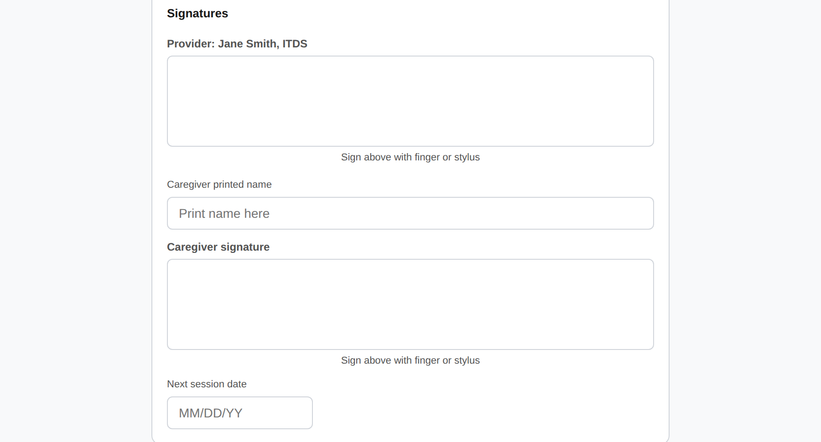
Signature capture on the Review & sign screen — you sign first, then the caregiver prints their name and signs, all on-device.
- ☁️ Cloud Roster — Your child roster is stored securely in the cloud — accessible from any device, not just one browser.
- 📄 PDF Export — Generate a clean, printable PDF of each completed note for your records and upload to ESDS.
- 📂 Notes History — Notes saved with the Save to Drive feature are kept per child in the cloud, so you can reopen or re-download prior sessions anytime while signed in with Google.
- 🔐 HIPAA BAA — A Business Associate Agreement is presented and signed before first use — required for HIPAA compliance.
🚀 Getting Started
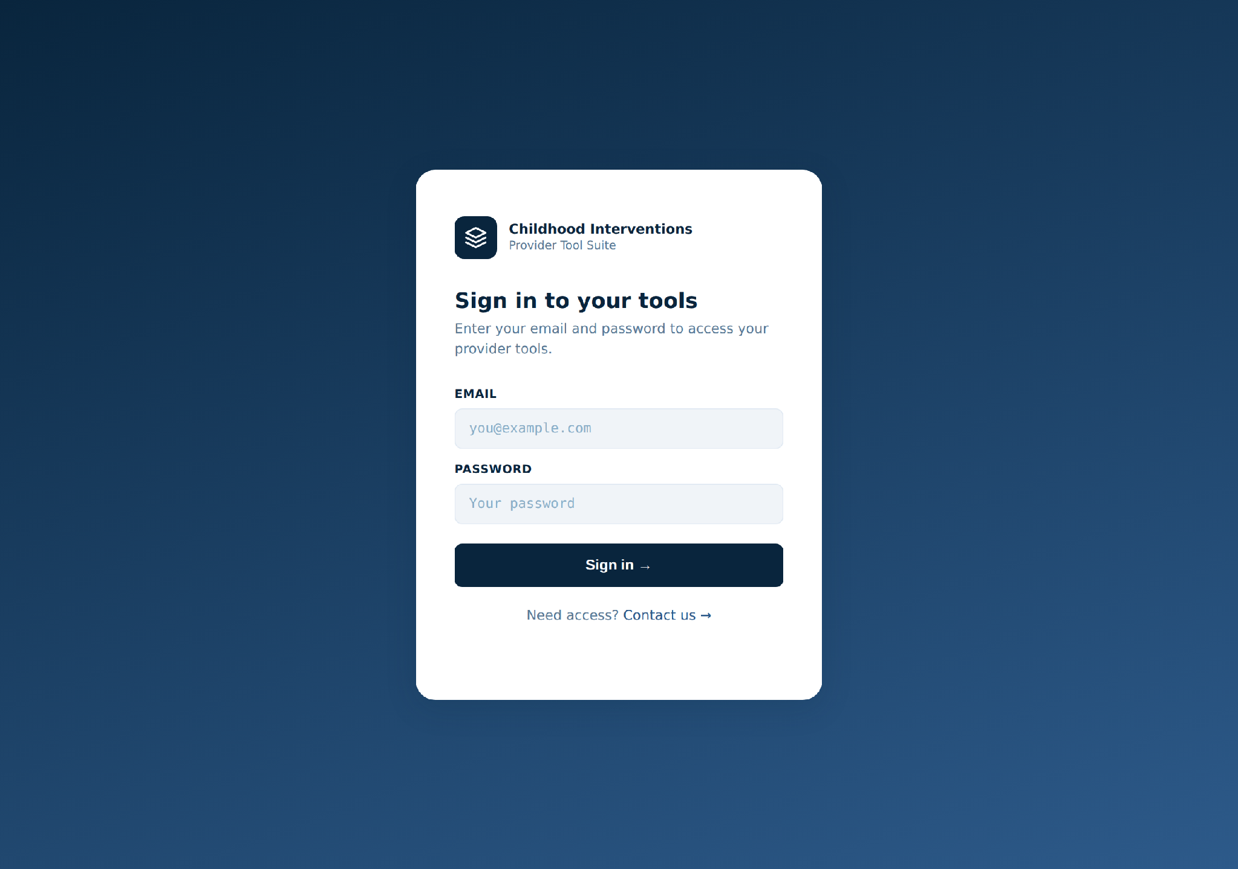
The Childhood Interventions Provider Hub sign-in. Your email and password open every tool in the suite.

1 | Sign in to the Provider Hub  Go to tools.childhoodinterventions.com and enter your email and password. Click Session Notes from the dashboard.

2 | Sign the Business Associate Agreement(BAA)  On first use, you'll be presented with a HIPAA BAA. Enter your full legal name and organization name (for Independent Providers it can be your name), check the confirmation box, and click I Agree — Sign and Continue. This is required by law and only done once.

3 | Set up your provider profile  Enter your name, credentials (optional), and organization name (for Independent Providers it can be your name). This information prints on every note PDF you generate. Click Save and continue.

4 | Add your first child to the roster  From the Roster view, click Add Child and enter the child's name and date of birth. You can add more details later. Your roster is stored in secure cloud storage.

💡 Already have a roster? If you previously used the tool and stored children in your browser, you'll be offered the chance to migrate that roster to cloud storage — choose Migrate my roster to make it available on any device.

✍️ Writing a Session Note
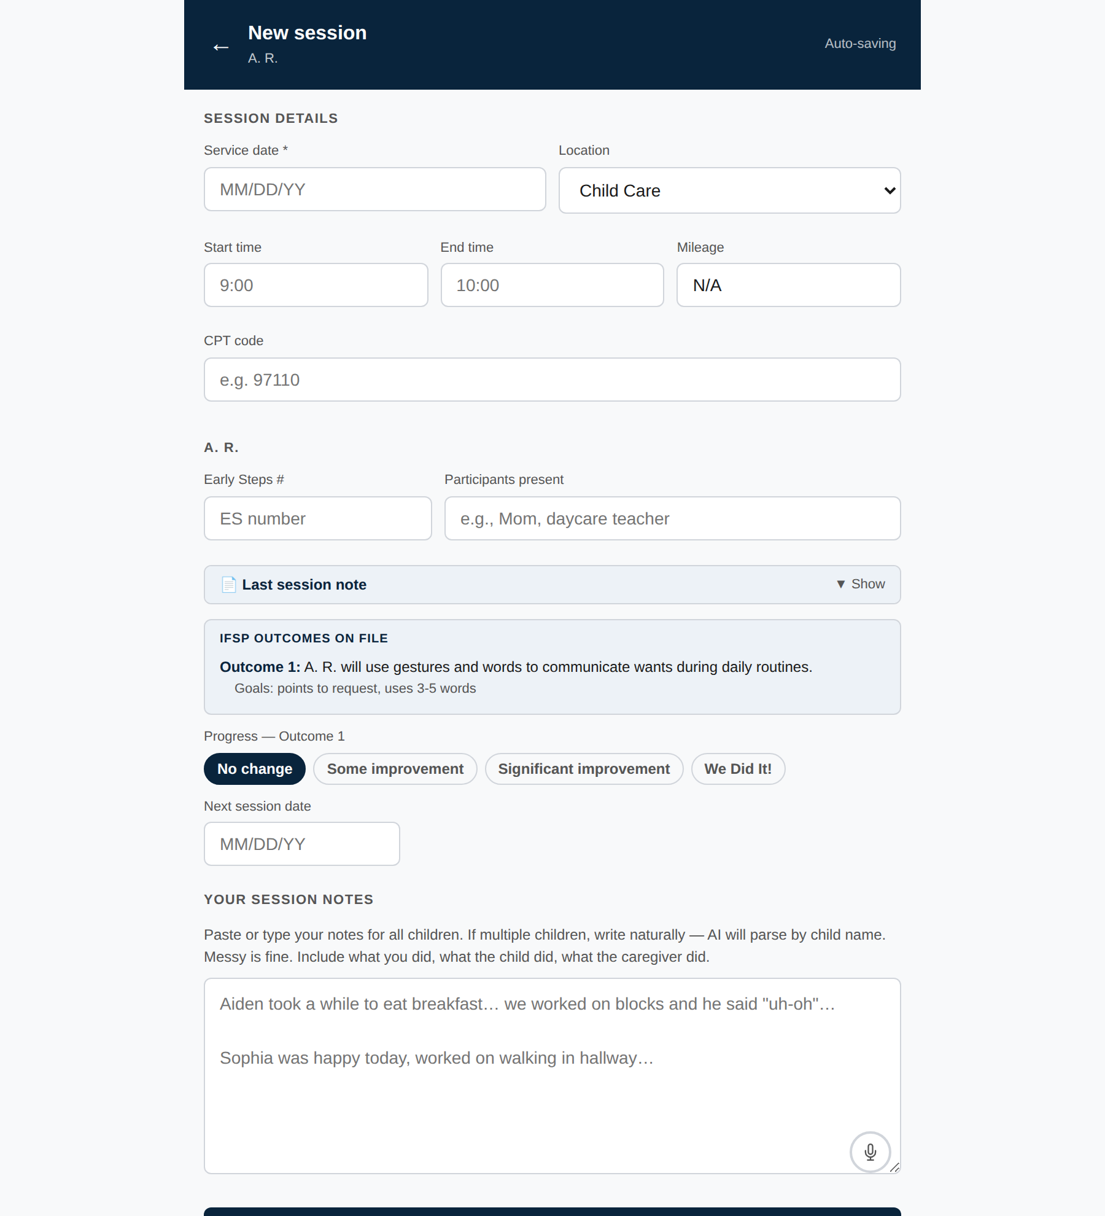
The session screen. Enter the session details, then type or dictate your notes in “Your session notes” — as the prompt says, messy is fine. Tap the microphone (bottom-right of the box) to dictate instead of typing.
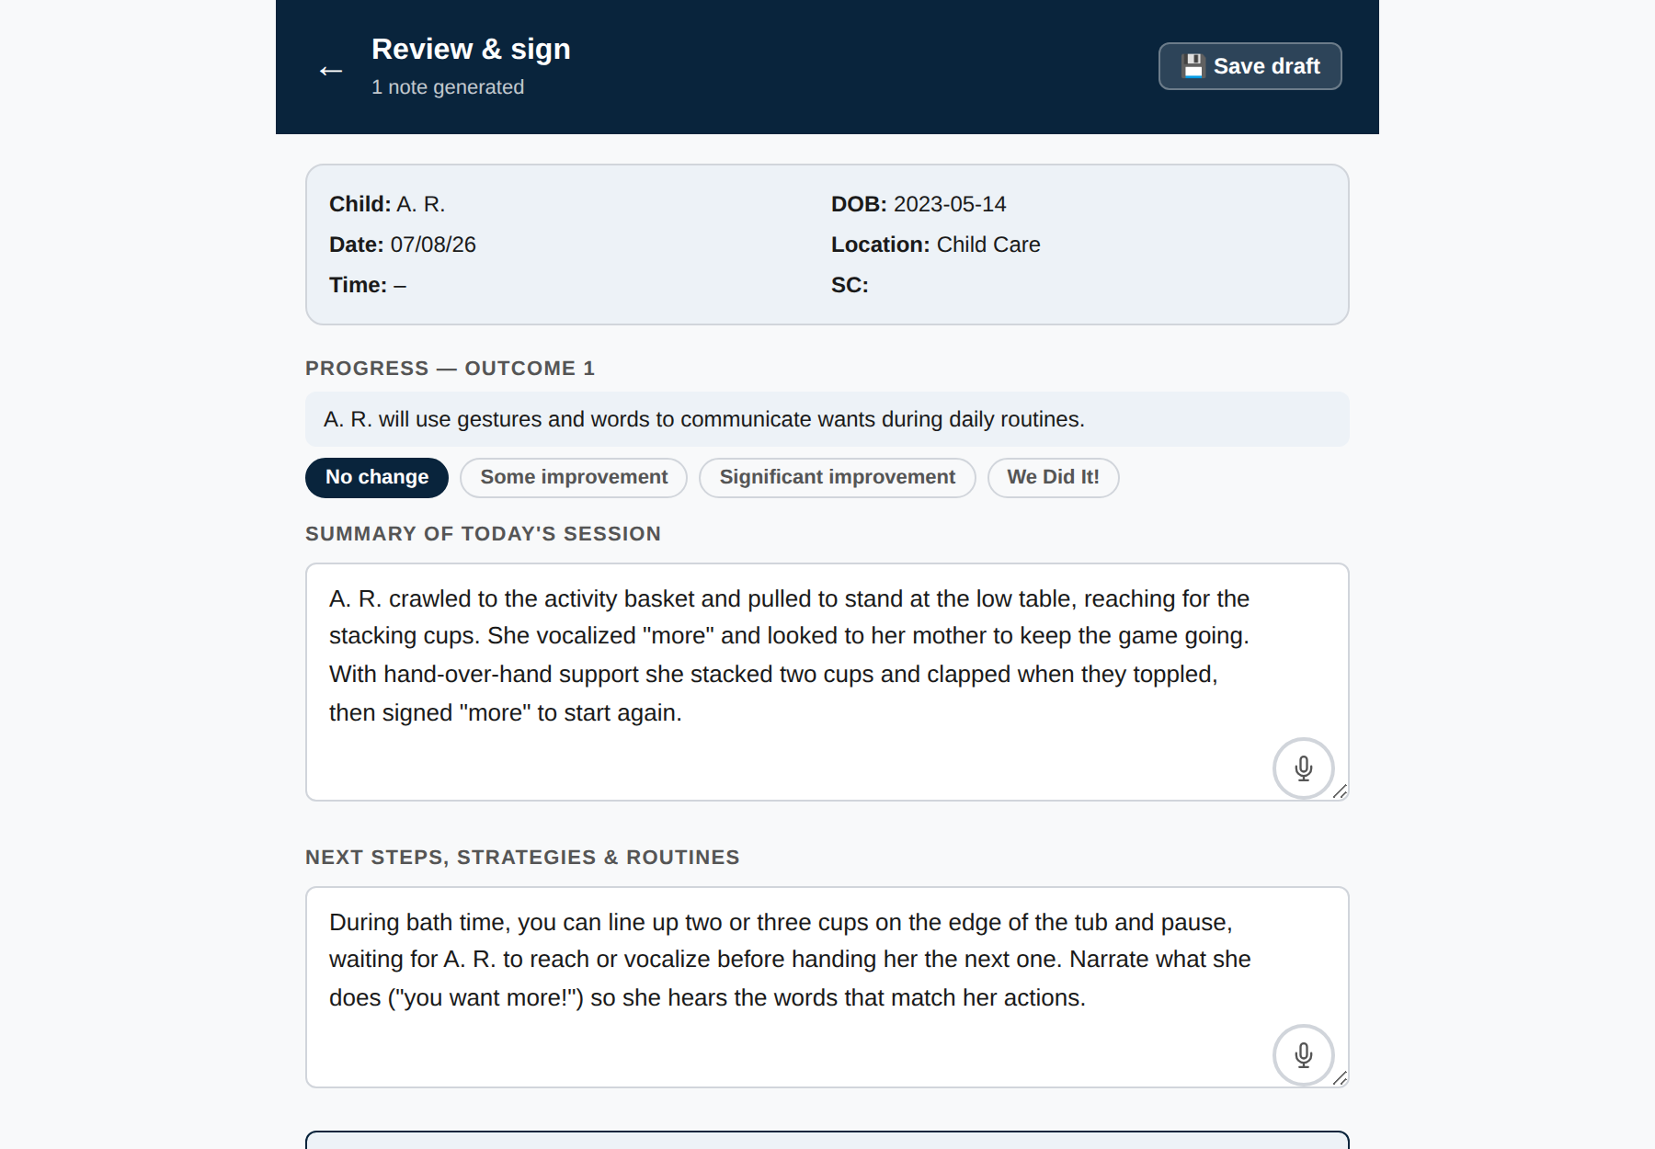
The AI-drafted note on the Review & sign screen. Edit the Summary and Next Steps freely; each field has its own microphone for dictating changes.
Each session note documents an individual visit. The tool walks you through the required fields — and here's the key thing to know: you don't have to write polished, formal language yourself. Jot down messy, shorthand notes (or dictate them out loud) and the AI turns them into a clean, ESDS-compliant narrative for you to review.
1 | Select the child from your roster  Tap the child's name on the Roster screen, then choose Start Session. If you have a saved draft, you'll see an option to Resume Draft instead.

2 | Fill in session details  Enter the session date, duration, location, and EI activity details, caregiver coaching provided, and child/family responses. Required ESDS fields are clearly marked.

3 | Jot messy notes or dictate them with the microphone  You don't need to type complete sentences or clinical wording. Enter your observations however is fastest — bullet points, abbreviations, and quick phrases are perfectly fine. Prefer to talk? Tap the 🎤 microphone icon in the notes field and simply speak; your words are transcribed straight into the note. The AI cleans up your messy input and drafts the family-friendly, ESDS-ready language for you in the next step, so you can spend your time with the family instead of writing.

3 | Jot messy notes — or dictate them with the microphone  You don't need to type complete sentences or clinical wording. Enter your observations however is fastest — bullet points, abbreviations, and quick phrases are perfectly fine. Prefer to talk? Tap the 🎤 microphone icon in the notes field and simply speak; your words are transcribed straight into the note. The AI cleans up your messy input and drafts the compliant, ESDS-ready language for you in the next step, so you can spend your time with the family instead of writing.

4 | Generate the note  When all required fields are complete, click Generate Note. The AI drafts a compliant session note based on your inputs — this usually takes 10–20 seconds.

5 | Review and edit the draft  The generated note appears in a text editor. Read through it carefully, make any corrections or additions, and ensure it accurately reflects the session. You are the clinician — always review AI output.

6 | Collect signatures and download the PDF  You sign first, then hand the device to the caregiver to sign. Once both signatures are in place, click Download PDF to save the completed note to your device.

⚠️ Always review AI-generated text. The AI drafts note language based on what you enter — but you are responsible for clinical accuracy. Edit anything that doesn't precisely reflect what happened in the session before finalizing.

✍️ Caregiver Signatures
The tool includes a built-in signature capture pad so caregivers can sign directly on your device — no paper forms or separate signature apps required.
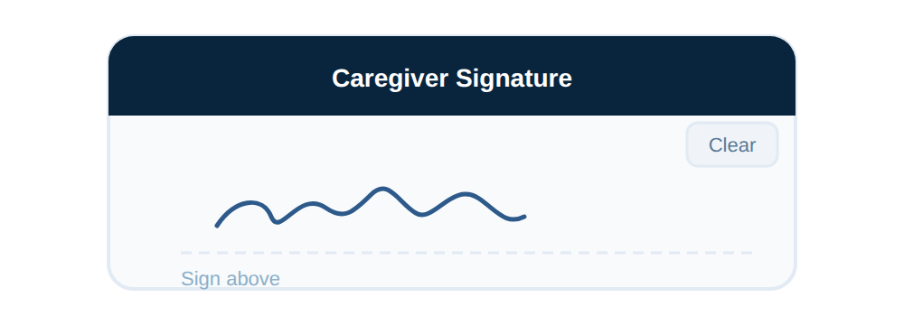
Workflow overview.
1 | Check the review checkbox  Before signatures are enabled, check the box confirming you have reviewed and approve the AI-generated note. This unlocks the signature fields and the Download button.

2 | You sign first  Draw your provider signature in the signature box. Your name appears as the label above it.

3 | Type the caregiver's printed name  Enter the caregiver's name in the printed name field below your signature.

4 | Hand the device to the caregiver to sign  The caregiver draws their signature in the caregiver signature box below. If they make a mistake, they can tap Clear and try again. Signing is the action — there is no separate Accept button.

ℹ️ Both signatures are embedded in the PDF when you click Download PDF. The session date appears next to each signature — not the time of signing. Signatures are not stored separately from the PDF. A caregiver who declines to sign should be noted in the session narrative.

💾 Saving & Exporting
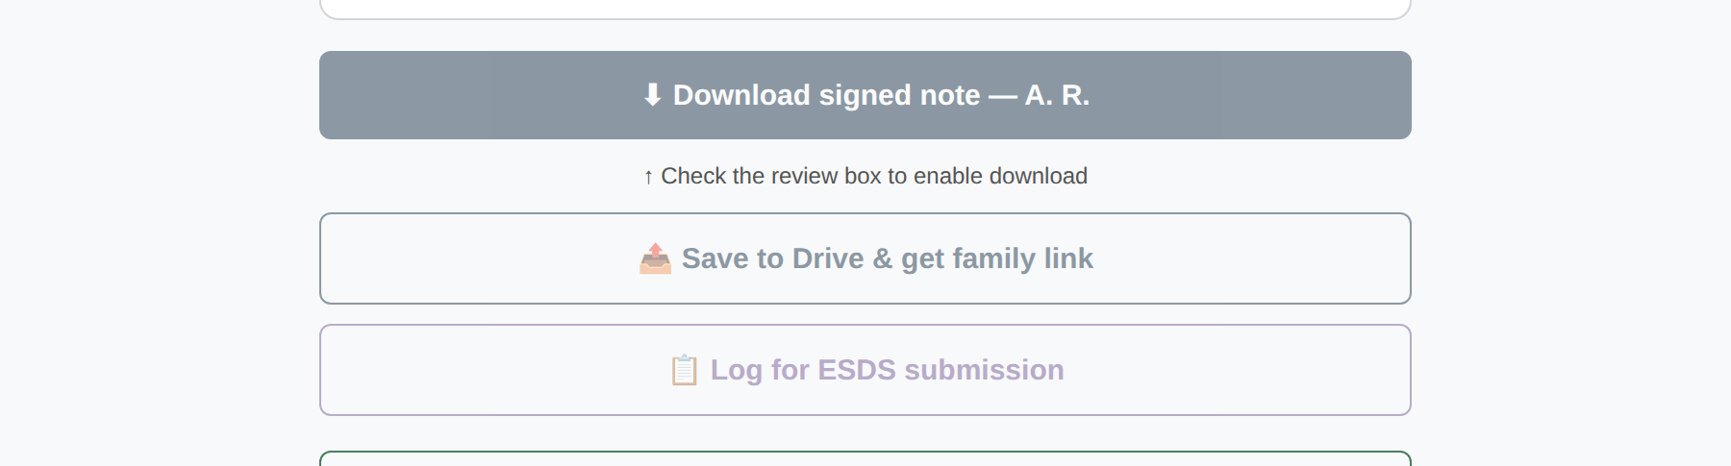
Finishing a note: Download the signed PDF to your device, or Save to Drive & get family link to file it in the shared Google Drive and share a 7-day link.
Understanding how your notes are saved helps ensure you never lose work. Drafts stay in your browser automatically; completed PDFs live on your device or optionally in Google Drive.
What | Where it's saved | When | PHI stored?
Session draft | Your browser (localStorage) | Auto-saved every 30 seconds | Yes
Child roster | Secure cloud | Immediately on save | Yes
Completed note PDF | Your device (download) | When you click Download PDF | Yes
Save to Drive | Shared Google Drive: [child] ▸ Session Notes ▸ <date>_session.pdf (+ 7-day family link) | When you click Save to Drive & get family link | Yes
ESDS billing log | Your Google Sheet (CONT or Medicaid tab) | When you click Log for ESDS submission | Yes
Unified Google Drive layout — all three provider tools now save into one shared Google Drive, organized by child, so a child's session notes, COS, and reviews live together:
Session Notes (shared drive) ▸ [child] ▸
├─ Session Notes ▸ <date>_session.pdf
├─ COS ▸ COS_<name>_<type>_<date>.docx
└─ Review ▸ <YYYY-MM> ▸ <child>_progress_summary.docx

💡 Draft auto-save: Backing out of the Review & Sign screen with the ← arrow auto-saves a draft of your summary edits, next steps, caregiver names, and progress levels — so in-progress work is never lost. The draft is waiting the next time you start a session for the same child.

📥 Downloading a PDF: Click Download PDF after reviewing and signing. The draft clears automatically after download. Save the file to a HIPAA-compliant location and upload to ESDS as required. Do not store note PDFs in personal cloud storage (Google Drive personal, Dropbox, iCloud) unless those services have a signed BAA with your organization.

🔗 Save to Drive & get family link: This optionally uploads the PDF to your Google Drive and generates a link you can share with the family — the link expires after 7 days.

🔐 HIPAA & Privacy
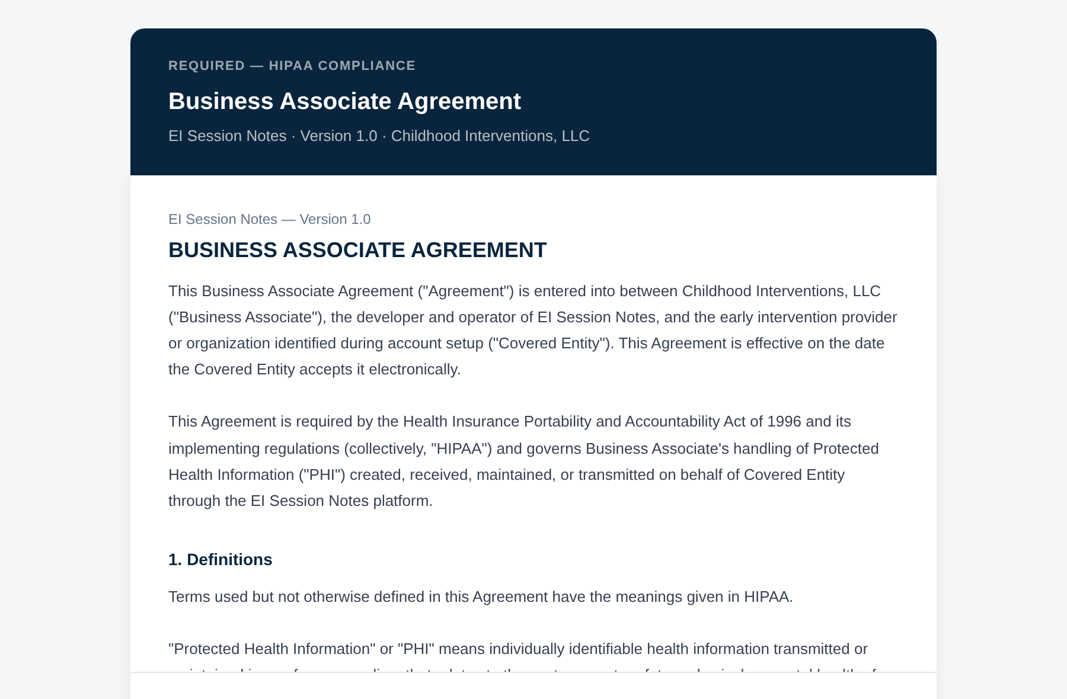
The Business Associate Agreement shown before your first note. Enter your name and organization, check the box, and sign — required by HIPAA, done once.
🛡️ This tool operates under a signed Business Associate Agreement (BAA) Childhood Interventions, LLC serves as a Business Associate under HIPAA. Before your first session note, you sign a BAA that establishes the legal framework for handling Protected Health Information (PHI). Your organization remains the Covered Entity responsible for patient data under HIPAA.

- 🔑 Access Control — Access requires a valid license key verified against our server. No key = no access to the tool or any child data.
- 🗄️ Encrypted Storage — Child rosters are stored in an encrypted cloud key-value store. Completed note PDFs are downloaded to your device — they are not stored on our servers.
- 🌐 Encrypted Transit — All data transferred between your browser and our servers is encrypted via HTTPS/TLS. Never transmitted over unencrypted connections.
- 🤖 AI & PHI — The AI generation process uses your session inputs. Do not include full child names or other PHI in free-text fields — use initials and child IDs instead.
Your responsibilities as the provider:
- Use the tool only on devices you control and that have screen-lock enabled.
- Do not share your log in with anyone outside your organization.
- Store downloaded PDFs only in HIPAA-compliant locations.
- Report any suspected unauthorized access to privacy@childhoodinterventions.com immediately.
- Do not photograph or screen-record session note screens in unsecured environments.
👨‍👩‍👦 Managing Your Roster
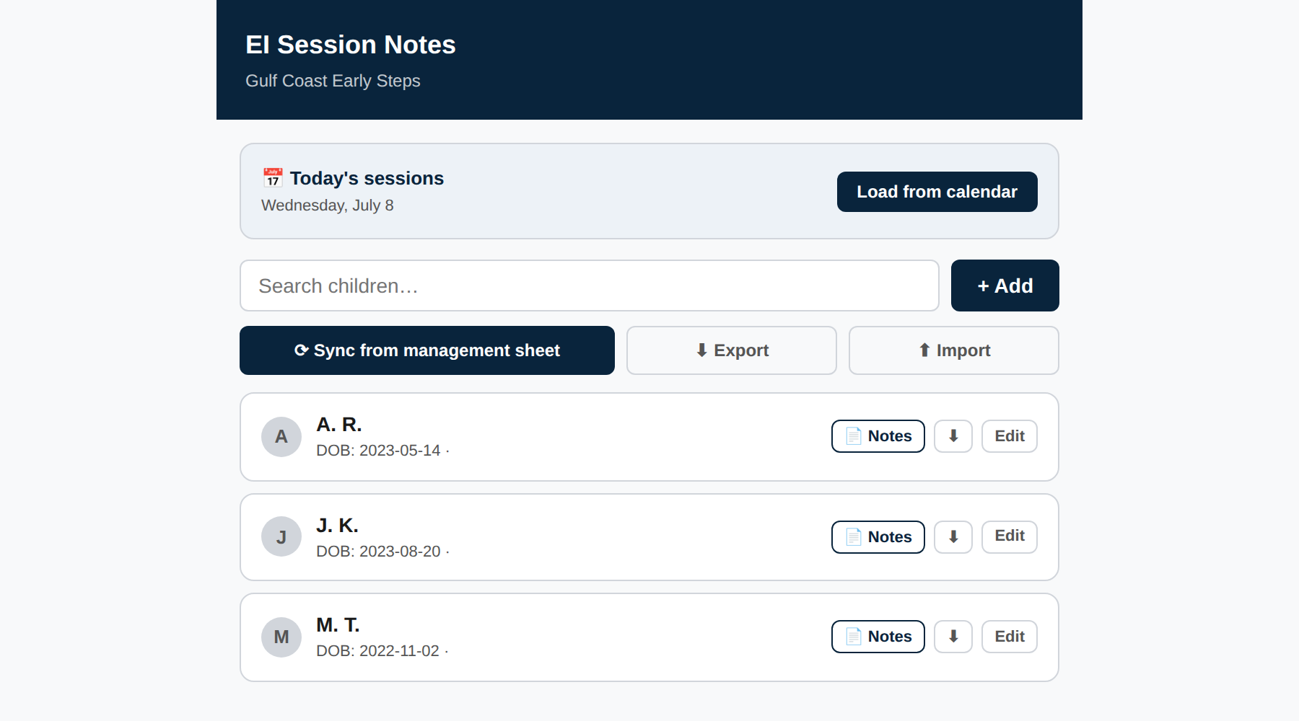
The roster — every child you serve in one place. Add a child, open Notes history, or edit a record; the roster syncs across your devices.
Your cloud roster keeps all the children you serve in one place. Roster data is available on any device you sign in from.

+ | Adding a child  Click Add Child on the Roster screen. Enter the child's name and date of birth. Other details (auth dates, diagnosis, etc.) can be added or edited later.

✏️ | Editing a child record  Tap the child's name to open their record. Use the Edit button to update any information. Changes are saved immediately to the cloud.

📂 | Viewing note history  Tap View Notes from any child's card to see that child's saved notes. History shows only notes you finalized with 📤 Save to Drive & get family link — those are stored in the cloud (and copied to your Google Drive). Notes you only saved locally with Download signed note, and unsaved drafts, won't appear here. You must be signed in with Google to view history, and you can re-open or download any prior PDF from this view.

🗑️ | Removing a child  Open the child's record and choose Remove from roster. This removes the child from your active roster but does not permanently delete completed note records (retained per your BAA).

💡 Tips & Best Practices
- ⚡ Use specific inputs — The more specific your session details, the better the AI draft. Include specific activities, targets, and responses — not just "practiced walking."
- 📱 Works on phones — The tool is fully mobile-responsive. You can complete the entire workflow — entry, AI generation, signature, PDF — on your smartphone.
- 🔄 Multiple devices — Your roster and completed notes sync across devices. Start a note on your phone in the field; finish it on your laptop at home (but we bet you won’t be finishing notes at home anymore!).
- 📤 Upload PDFs promptly — Upload completed note PDFs to ESDS within your organization's required timeframe. The tool doesn't auto-submit to ESDS — that step is yours.

